Angular Framework

Angular Framework is used to develop front end applications, it allows you to create applications which are called as client applications for variety of platforms like Mobiles, Desktops, Web and so on.

It is created by Google.

What is framework

Framework helps to build complex application easily by providing all the common features for an application inbuilt so that developers don’t have to write code for these common features, some of the common features most of the application needs are:

* Type conversion
* Internationalization
* Exception Handling

Angular Framework is a framework for front-end it uses two languages to develop the front end applications & it is used to develop single page application the two languages are:

1. HTML for displaying
2. Typescript for writing the logics

Typescript is a superset of JavaScript which is better than the Java Script

Note: Angular Framework uses CSS for styling

Single Page Application:

Single Page Applications will have one single page where you can perform all the tasks, it loads only part of the page when any action is performed and doesn’t refresh the entire page, ex: Gmail, Angular official website, React.js official website, Git Hub.

Single Page Application is much faster compare to multiple page applications, because in single page application you need to update only small part of the page not the entire page.

Software required

1. Node.js
2. Visual Studio Code
3. Angular CLI (Angular Command Line Interface) toolkit

Angular CLI

It is a toolkit released by Google to improve the development process

* It allows you to create a ready to run and build angular project
* It will have an inbuilt typescript compiler in the project which automatically compiles the typescript code to javascript code
* It will provide a live reload feature which will refresh the browser while you are typing the code
* It will provide an embedded server to run your angular application
* It will provide lot of angular commands to accelerate the development process, so that developers work will be reduced

How angular can create a single page application

Angular uses component to create the UI, these components are independent and reusable with other components.

Components: These are UI’s which you see in the web page, they can be created independently and nest in other components.

A single page application is a collection of multiple components

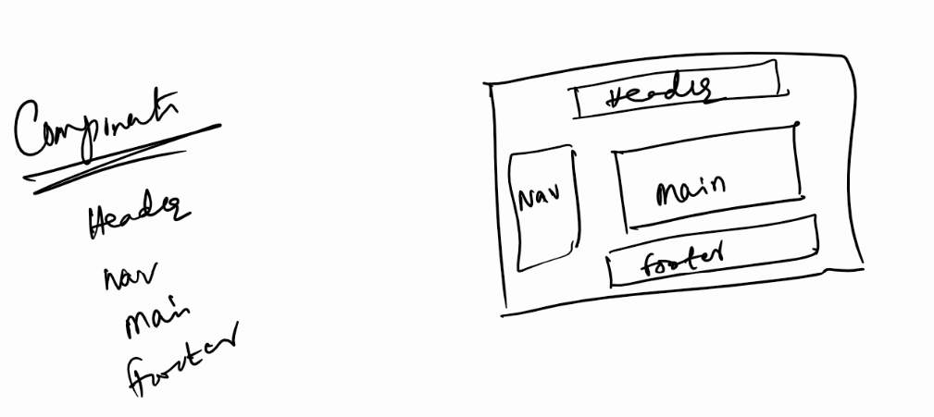

Angular CLI Installation

We should have node & npm installed already, because you will install angular cli using npm.

>> npm install -g @angular/cli

Note: Angular CLI is a one time installation, it gives you a command called ‘ng’ using which you can create angular applications & also run angular applications

After installing you can use ng --version

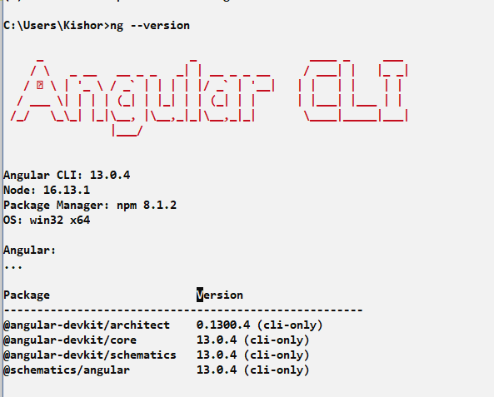

Command used to create angular project

>> ng new project-name

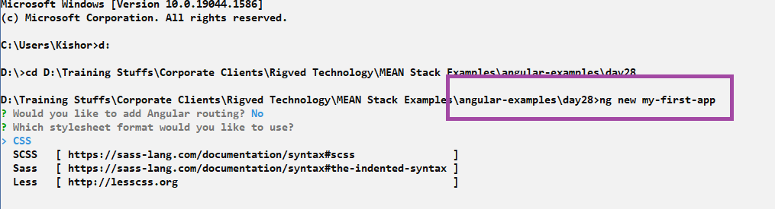

Once you install you will get the success confirmation

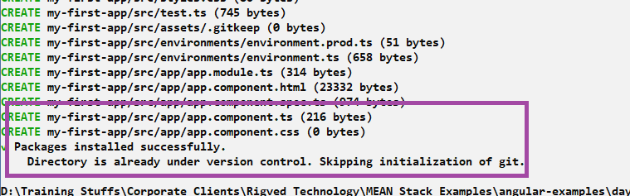

Purpose of *ng new <<app-name>>*

ng is an angular command

new is a keyword to create a new project

<<app-name>> must be the project name

Navigate to the project & use ng serve to run your project

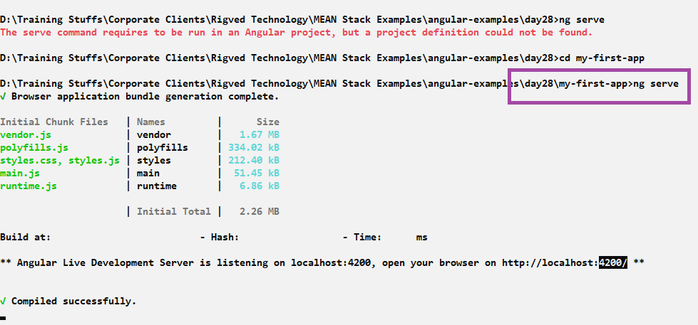

By default the project runs in 4200, which you can enter in the browser and by default every new project will have some default content which can be changed by adding UI’s in angular application according to your requirement.

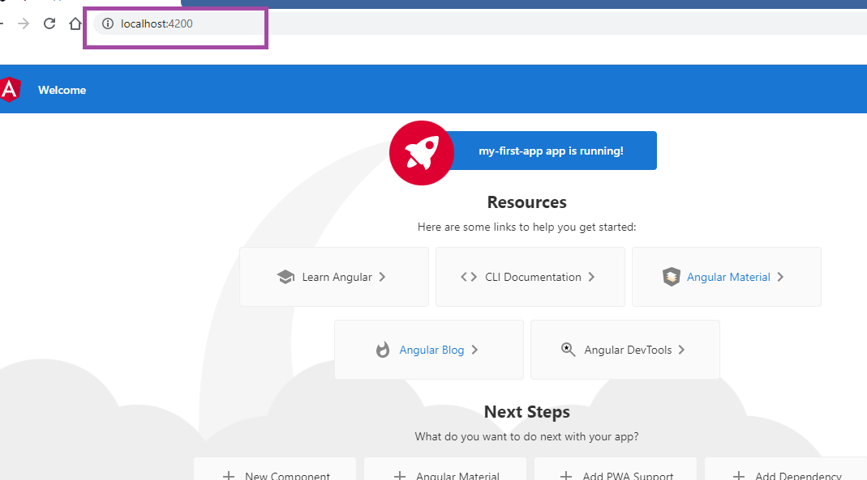

You can open angular project folder from the VS Code

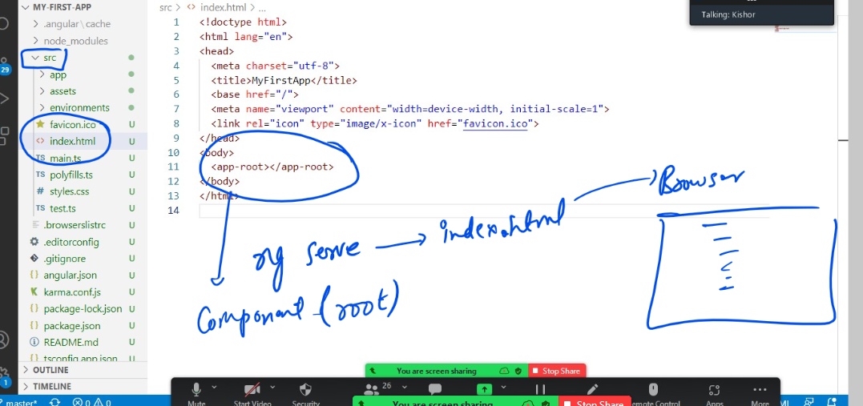

The moment you enter ng serve, angular loads index.html in the browser, that is only file which is loaded in the browser, but everything happens inside the index.html <app-root>, which is a root component, this root component can nest any number of components

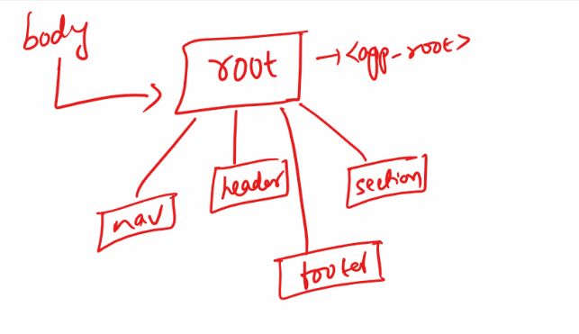

Every angular application must have one root component and it be only one root component all the other components are part of this root component.

<app-root>: This is the tag name for root component, when you use this tag the content of root component is displayed

Where’s the content of this <app-root>

src/app/app.component.html: This file has the content for <app-root>

How does angular knows <app-root> content is in app.component.html

It is mentioned in the src/app/app.component.ts

Two important files to know

app.component.html: It has root component content

app.component.ts: It has @Component({}) decorator which specifies the tag name for the root component and content for the tag

i.e., @Component({selector:’app-root’, templateUrl:’./app.component.html’})

@Component: It is a decorator which must written on top of the class when you want the class to behave like a UI component

Currently src/app/app.component.ts has below code not changed

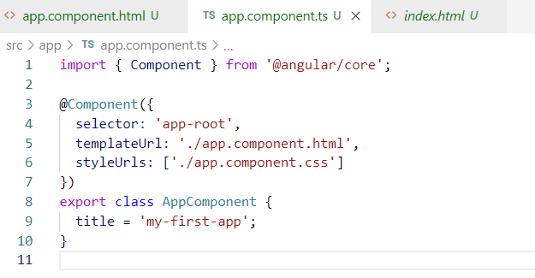

Modify the src/app/app.component.html to have a simple content

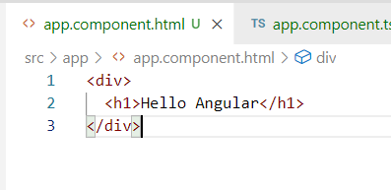

Angular can detect the changes and reload browser automatically

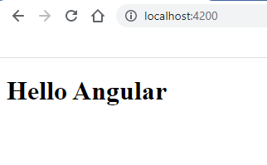

Note: The only file loaded in the browser is index.html & it must never be modified

Activity:

1. Try the above example as it is
2. Create a new project with the name my-second-app inside day28 folder and remove everything of src/app.component.html and add {{title}}.

Angular building blocks

1. Components
2. Modules
3. Databinding
4. Pipes
5. Services
6. Routers

Components: These are visible part in the page

Modules: This represents functionality of an entire application or part of the application, an angular application is a collection of all the building blocks which are part of an angular module called root module

Root module will have the entries of all the components, pipes, routers, services an so on. It represents an entire application.

Your angular project also have a root module in src/app/app.module.ts

This module is launched when you enter ng serve, this takes care of loading all the elements of the application.

@NgModule({}): It is decorator used to create the module

By default app.module.ts will have below entries

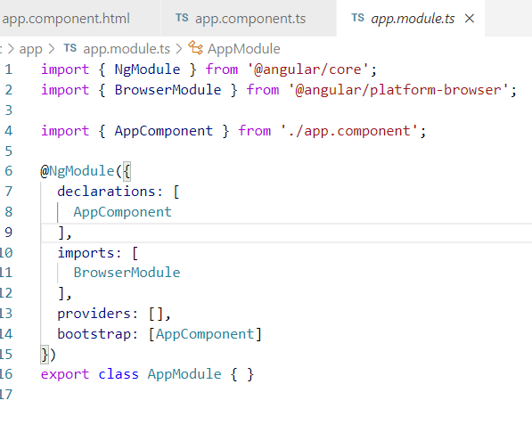

Here the declarations property mentions all the components you create in your application, any components you create is recognized by angular only if you declare in AppModule.

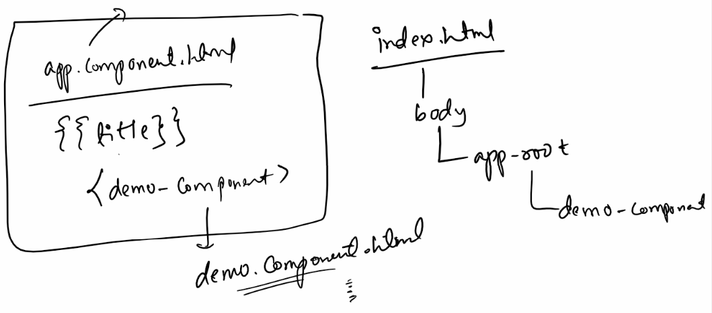

Creating our own components

1. Create a ts file
2. Create an html file
3. Mention the component in the app.module
4. Add your component(<demo>) in another component(app.componen.html)

app/demo.component.ts

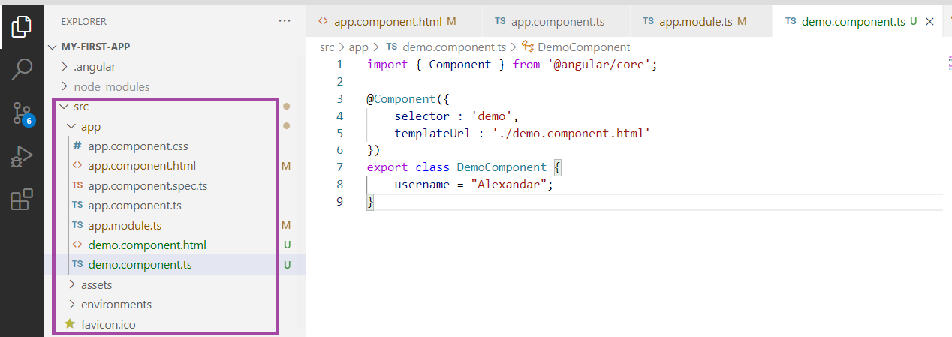

app/demo.component.html

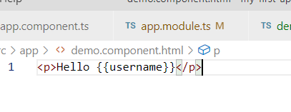

app/app.module.ts

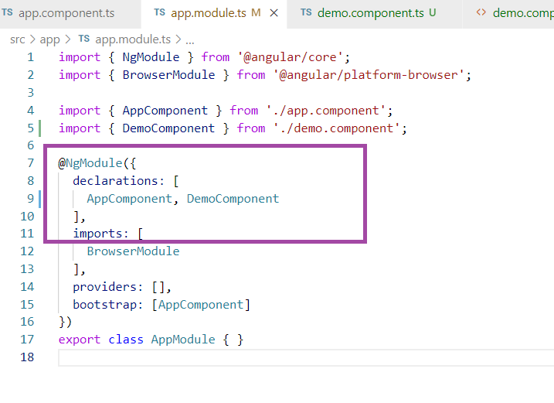

app/app.component.html

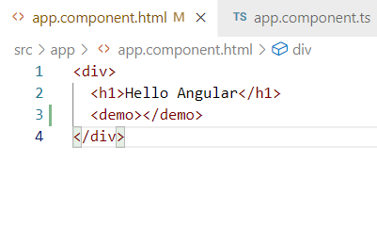

Output:

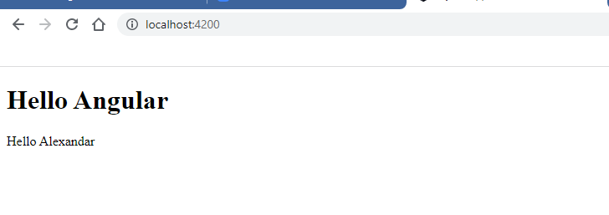

What happens when you use ng serve

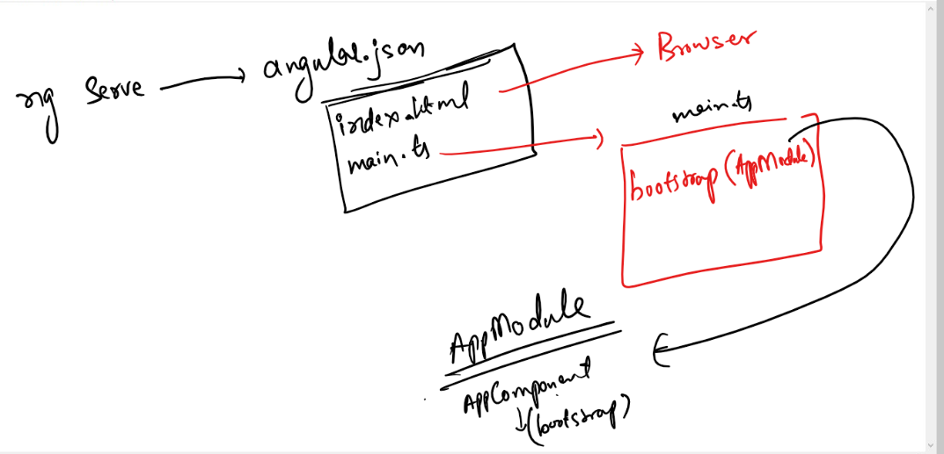

The ng serve is a script that looks for angular.json file which is a configuration file used by angular there it finds index.html and main.ts file as an entry point file, the index.html will be loaded in the browser & main.ts will be executed, the main.ts will have a code to bootstrap AppModule, since the AppModule represents everything of your application the main.ts is the one who loads your entire application by loading AppModule, the AppModule will have @NgModule({}) decorator that declares all the components, other building blocks of angular but bootstraps the root components as it is the very first component appears in the browser DOM tree.

Lets create another component in our angular application

You can create a component named user.component.ts which will have name & age properties in its class.

A class must have @Component({}) decorator to behave like a component, the @Component({}) must specify the selector & templateUrl,

selector: tag name of the component

templateUrl: content for the selector

You can use the selector in any other components either in root component or some other components also

@Component: It is a decorator used in angular to make class to behave like a UI component

Decorator: It is a name prefixed with @, it adds extra feature to the class, variables that helps them to have extra capability in the application, there lot of inbuilt decorators in angular which are used on top of the class / variables

If a class App{} is created it is just a normal class

If a class App{} is created by having @Component({}) on top of it, then it becomes component class, so that the class can share the data to the user and get the data from the user

Creating a user component inside app/user folder

Here the ‘user’ folder would have all the files related to user components like user.component.ts, user.component.html, user.component.css

src/app/user/user.component.ts

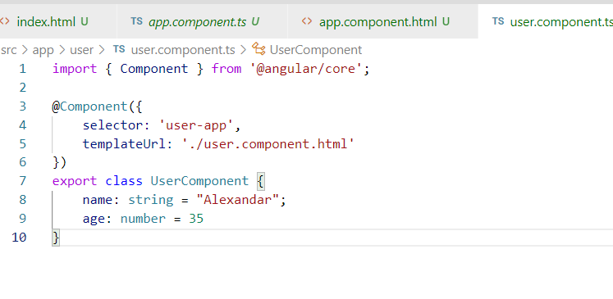

src/app/user/user.component.html

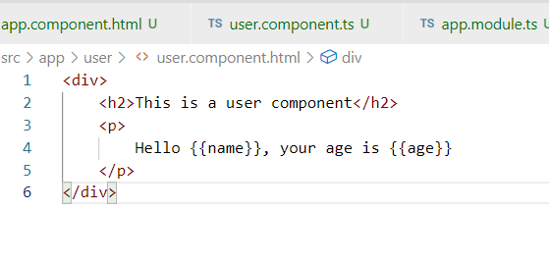

Register the UserComponent in the AppModule

src/app/app.module.ts

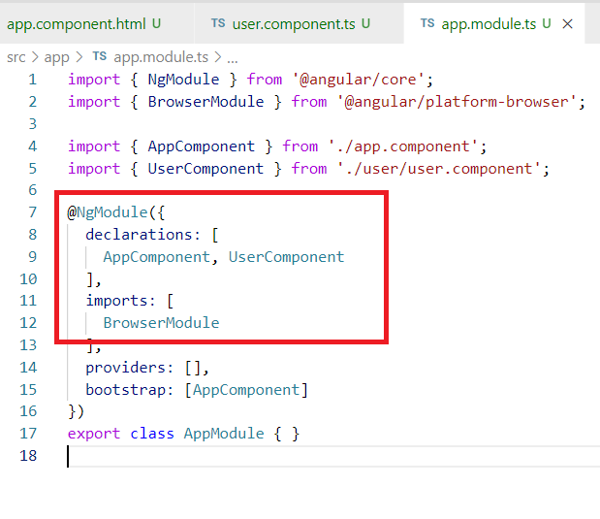

Add the user component in any other components which is part of the root component, since we have only two component here i.e., UserComponent and AppComponent we are adding UserComponent in AppComponent, but it must be added by tag names i.e., selector i.e., <user-app>

src/app/app.component.html

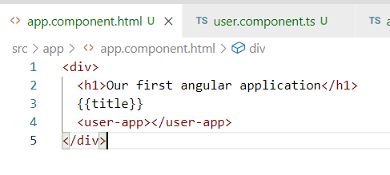

Output:

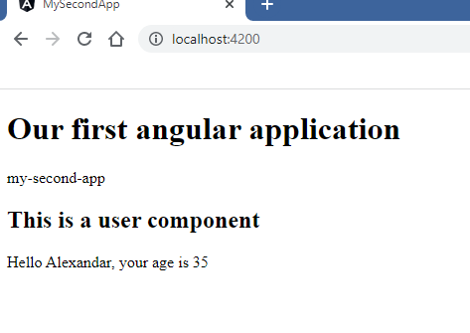

Templates for the components

These are the contents written for the component selector (tags), it can be written externally using templateUrl or internally using template which is treated as inline template

@Component({  
 selector:’tag-name’,  
 template: ‘content’  
})

The above component uses inline template, this you can use when the component has only few content, but still you can use external template to get the advantages of the auto-suggestions.

Inline template example

app/demo/demo.component.ts

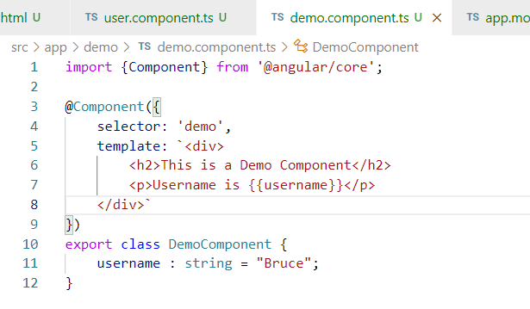

template is used to create an inline content for the component, but it is suitable only when you have a very few lines of contents, if the component contents are more, then you can use templateUrl

Register the DemoComponent in the AppModule app/app.modoule.ts

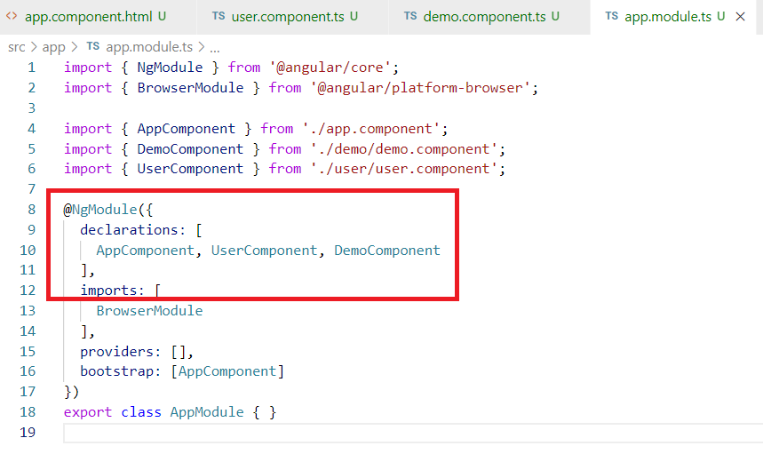

Add the DemoComponent in root component

app/app.component.html

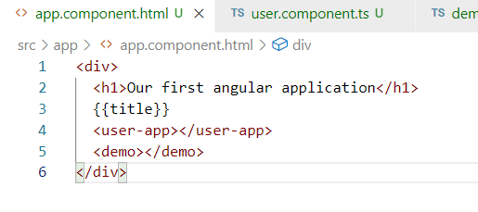

Note: You can add your components in other components also apart from the root component, i.e., you can add demo component int the user component if required

Output:

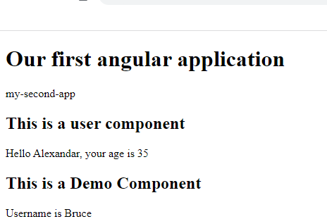

Let us add <demo> component in the UserComponent i.e., user.component.html

user.component.html

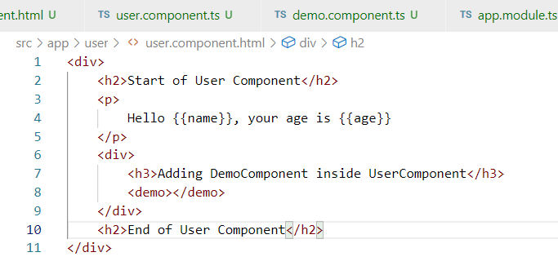

demo.component.ts

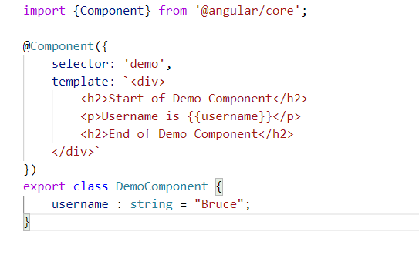

app.component.html

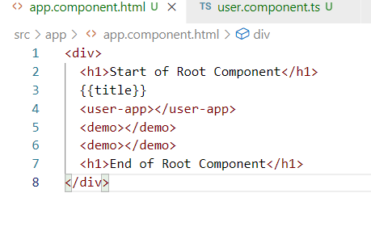

Output:

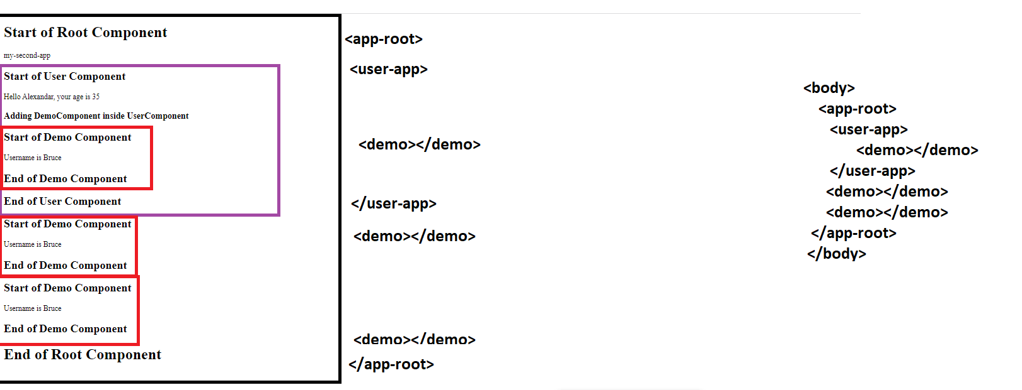

Browser DOM tree structure

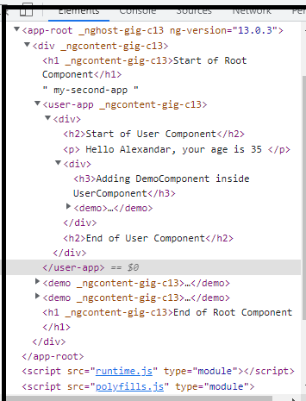

How to style these components

For every components there is a local CSS which applies styles only to the component it is bound to, you can also use global CSS which applies styles to all the components.

Local CSS:

The @Component({styleUrl: [path]}) would mention the Local CSS, where you can apply styles to a particular component

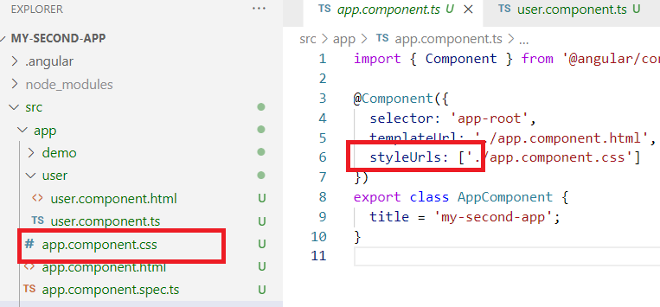

Note: You can create CSS for each component and reference it by using stylesUrls

Global CSS

You have a styles.css file in the angular project, that applies CSS to all the components

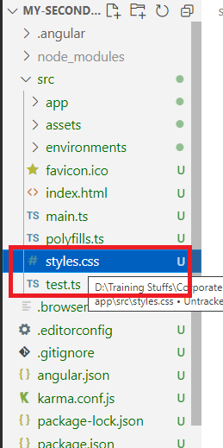

Let us add style to the app/app.component.css

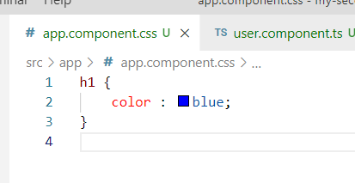

You can see all the <h1> in app.component.html taking blue color

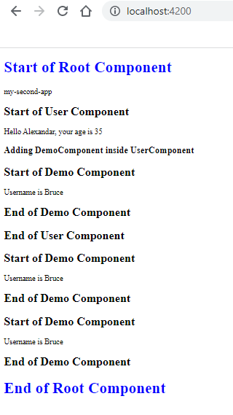

Note: We can create local CSS for the other components

src/app/user/user.component.css

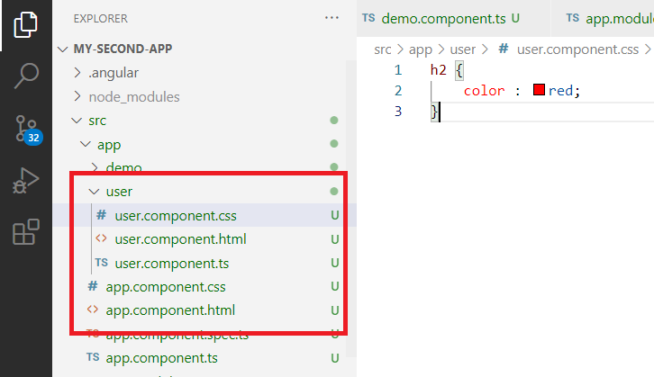

Modify src/app/user/user.component.ts

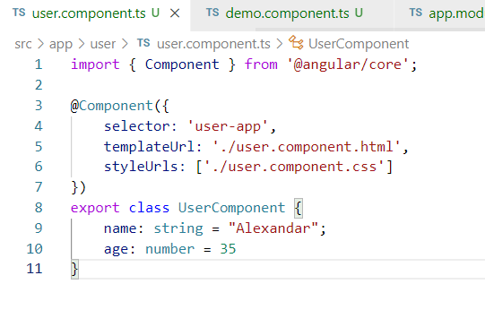

Output:

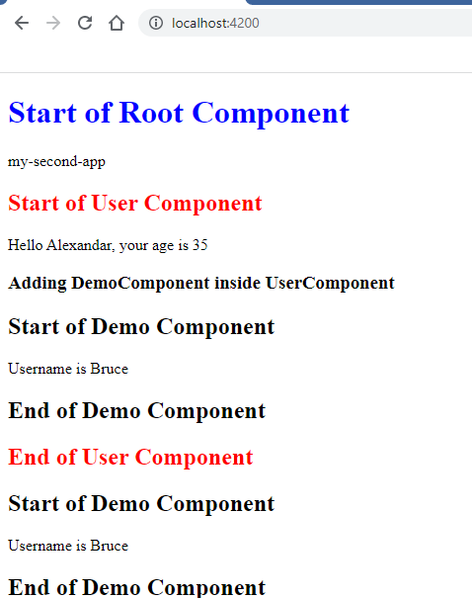

Summary:

* ng serve: launches the application by executing main.ts and loading index.html
* AppModule: Root module that represents entire application, this will have all the elements the application should recognize
* AppComponent: Root component which is parent to all the other components
* After creating the component you need to register in the app.module.ts i.e., in the declarations of @NgModule({})
* Inline Template: It is used when the component itself wants to have the content
* styleUrls: It is for adding styles to the particular component, it is a Local CSS
* styles.css: It is for adding styles globally.

Angular CLI commands

Angular provides many inbuilt commands to improve the development speed, these commands are entered with ‘ng’ command

ng generate component component-name (or) ng g c component-name: This is the command which creates .ts, .css, .html files for the components & it also registers the component in the app.module.ts

ex: ng g c demo: This creates 4 files and upates the app.module.ts, those 4 files are

1. demo.component.ts
2. demo.component.css
3. demo.component.html
4. demo.component.spec.ts

Apart from creating these files it will also add some code in some files that developers repeatedly write.

ie..,

@Component({  
 …

})   
export class DemoComponent { }

Apart from ng g c we have many useful commands like

ng generate service service-name (or) ng g s service-name

ng generate pipe pipe-name (or) ng g p pipe-name

ng generate guard guard-name (or) ng g g guard-name

All the above commands we are going to see in future

Using ng g c command

To enter this command you must have a separate command prompt that is inside the project folder.

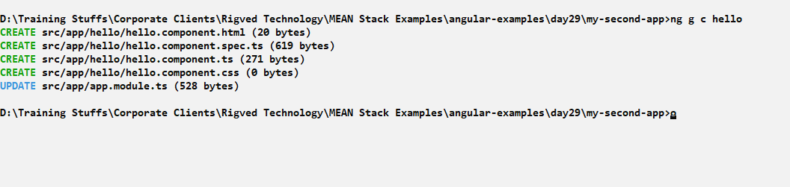

The component is ready to use in other components, you can add in the app.component.html to see the default content i.e., hello works

src/app/app.component.html

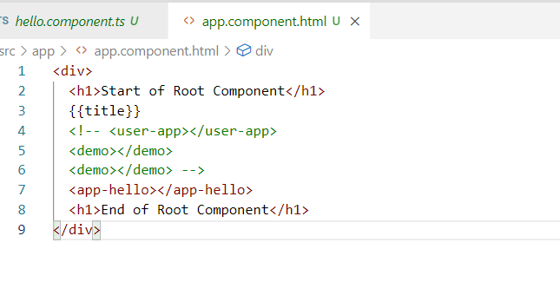

Output:

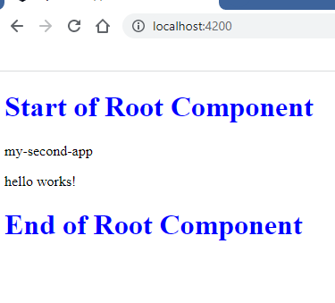

Day 30:

ng serve --port 4201

The above command runs the application in 4201 port instead of 4200

Command to generate component

ng g c component-name

The above command creates templateUrl to represent the view outside the component class

@Component({  
 selector : ‘tag-name’,  
 templateUrl: ‘url’  
})

Command to generate component with inline template

ng g c component-name --inlineTemplate=true

The above command generates the component and view will be part of the component class as below

@Component({  
 selector : ‘tag-name’,   
 template: ‘<p>component wroks</p>’  
 styleUrls: []  
})

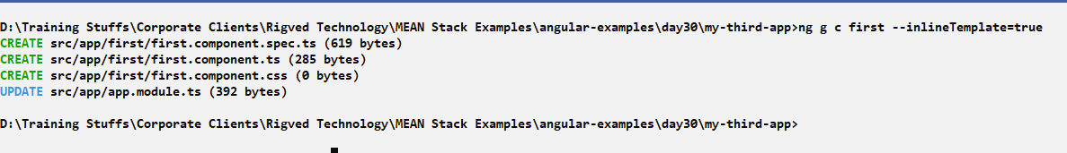

first.component.ts

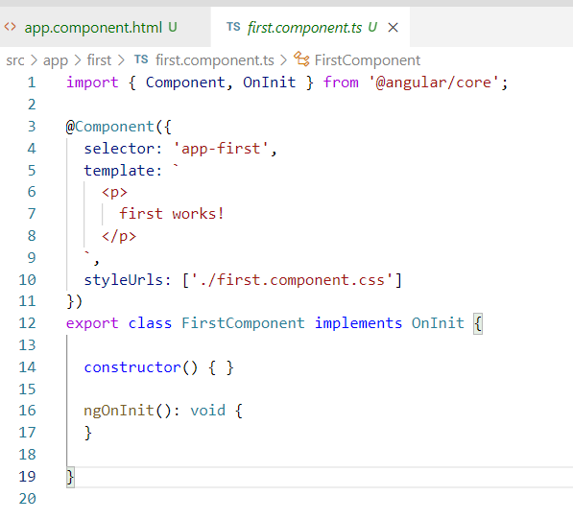

To see the first component content you must add its selector/tag-name in the root component

app.component.html

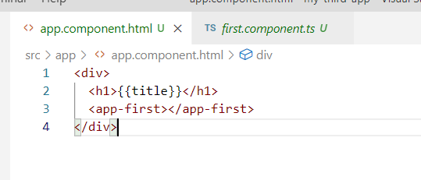

Output:

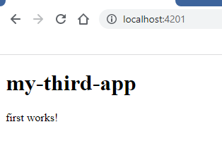

Angular Pipes(|)

These are the features in the angular which can format the output so that the content will be transformed to something else instead showing the original content, angular provides lot of inbuilt pipes that can use in the component template using pipe symbol(|), the inbuilt pipes are

uppercase, lowercase, currency, date, json

{{data | uppercase}}: The data will be shown in uppercase

{{data|lowercase}}: The data will be shown in lowercase

{{data|currency}}: This data will show the number in currency format, by default it will be $, but you can pass arguments to the pipes if you need some other currency symbol

{{data | currency : ‘INR’}}: Here the currency is the pipe name & INR is the argument that specifies the condition what the currency should be in, it will show rupee symbol

{{data | date}}: Shows data in default date format, but it can be formatted according to the requirement

{{data | date: ‘MM-dd-yyyy’}}: Date will be in MM-dd-yyyy format

{{data | json}}: Converts the javascript object to json and shows that json to the user

Note: The data must be of right type when we are formatting, else it doesn’t work, ex: If currency is applied then it must be applied on number type data only.

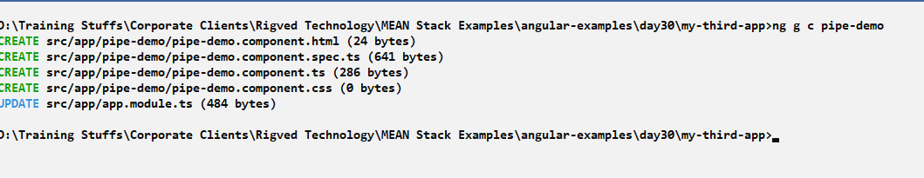

pipe-demo.component.ts

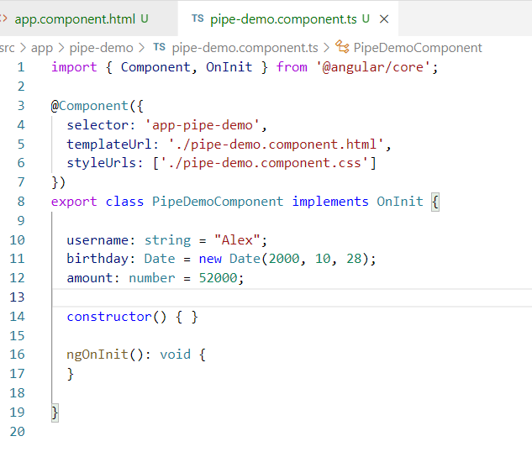

We have username, birthday, amount in the component class that can be formatted using the inbuilt pipes

pipe-demo.component.html

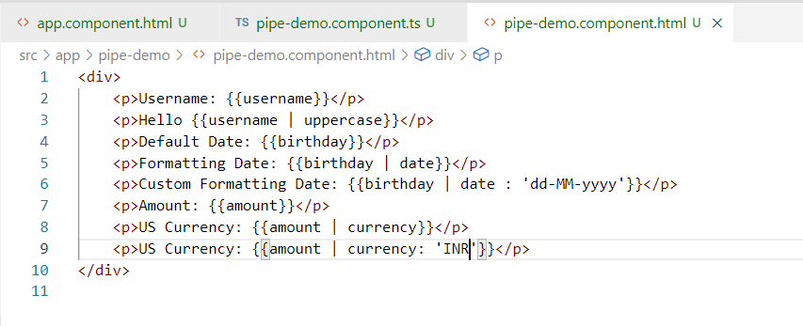

Note: Add this component to the root component

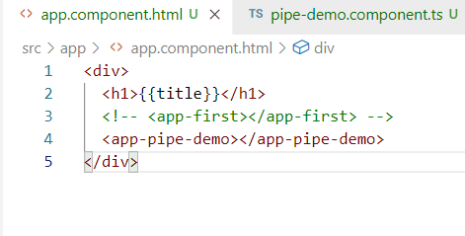

Output:

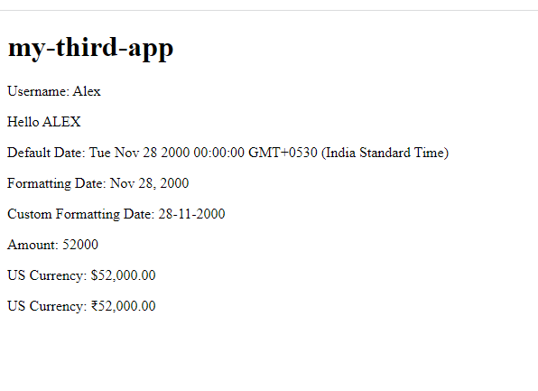

Custom pipes:

These are created when you need your own pipes for transforming the data when the predefined pipes doesn’t help your requirement

PipeTransform: It is an interface a class must implement while creating the custom pipe, the PipeTransform has a function called transform() that is executed when the custom pipe name is used, the data transform returns would be the transformed data that comes after applying the pipe

@Pipe: It is used to decorate a class to act like a pipe, it will have a name which is used while transforming the output,

Note: A class that implements PipeTransform must have @Pipe decorator, it must be registered in the AppModule so that angular calls the transform() function at runtime automatically by passing arguments to the transform() whenever the pipe is used

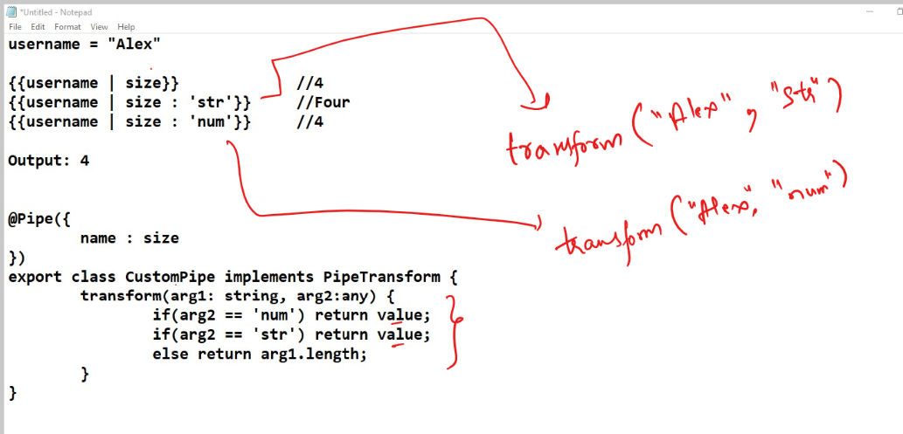

src/app/custom-pipe.ts

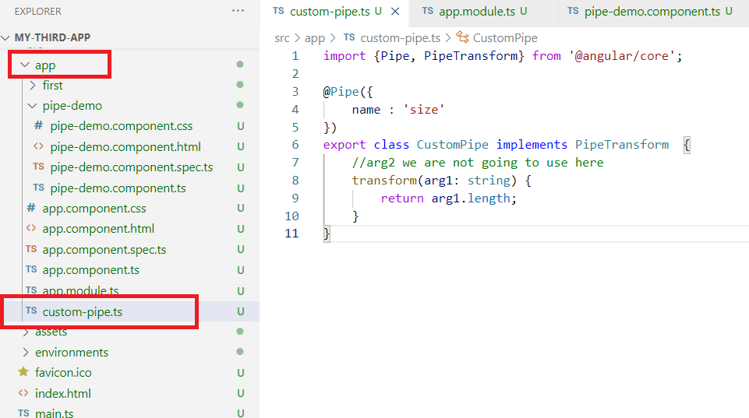

The ‘size’ is the pipe name which needs to be used when you want to transform, but angular needs to know this pipe name hence you must register in app.module.ts

app.module.ts

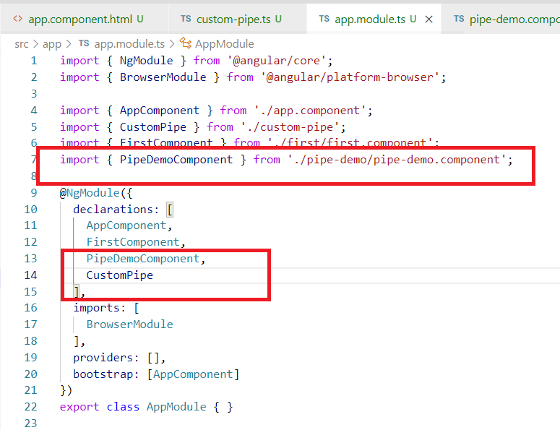

Now you can use the pipe name size anywhere you want and see the size of the string

pipe-demo.component.html

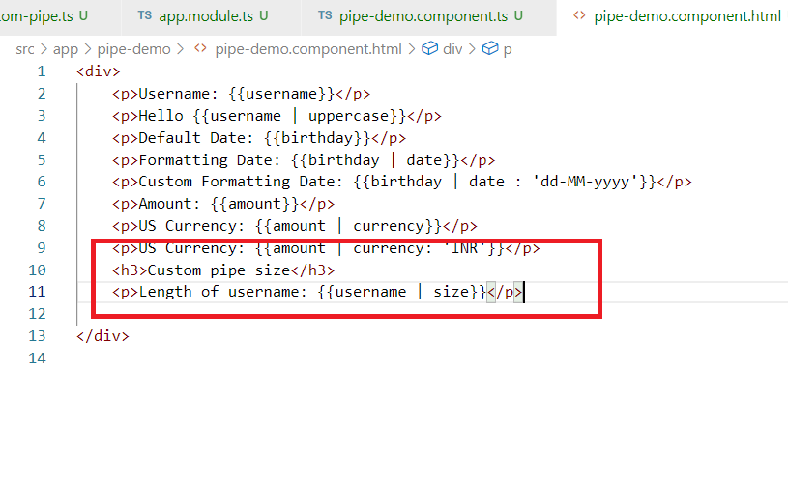

Output:

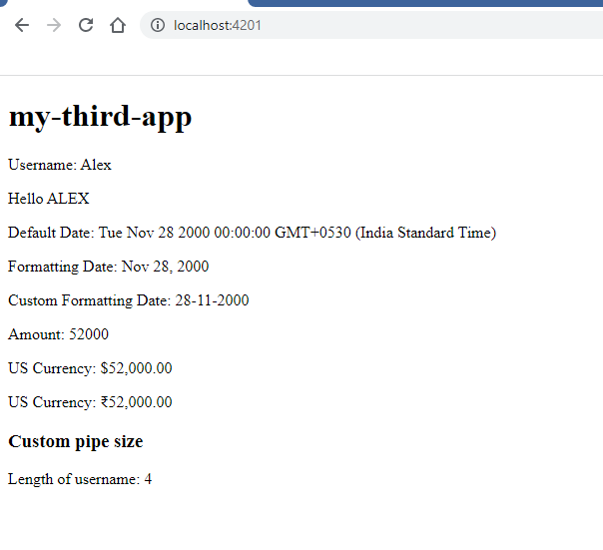

Structural Directives

These are like attributes that you can use in the view template element, it works with the DOM Structure whether to show or hide the element or to add the elements at runtime

We have 2 structural directives:

1. *ngIf
2. *ngFor

*ngIf: It is used when the element needs to be shown or hidden

ex: <p *ngIf = “property”>Some content</p>

Here the content will be shown when the component property value exists/true else it will be hidden when the property is false/undefined

*ngFor: It is used to iterate the array present in the component class, it allows you to dynamically add the elements in the DOM

ex: <p *ngFor = “let i of items”>{{i}}</p>

Here ‘i’ is an iterator to iterate the elements present in the ‘items’ array

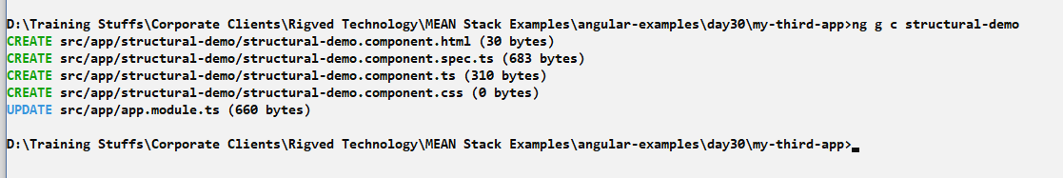

Add the structural-demo in the root component

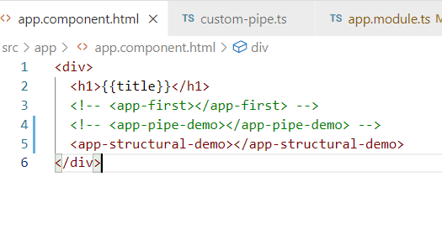

structural-demo.component.ts

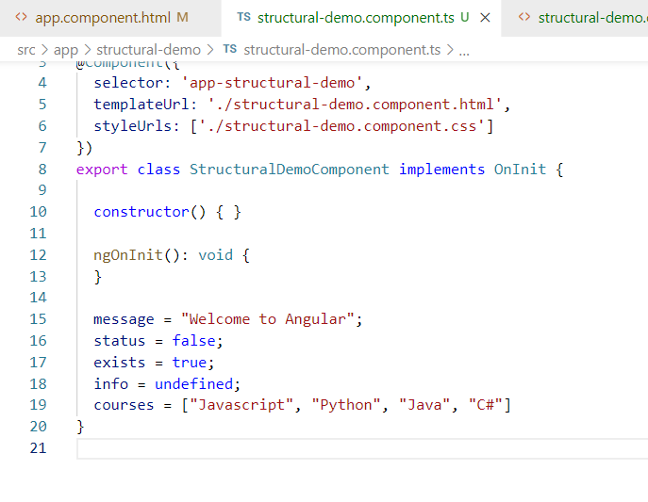

You can use *ngIf for all the properties and *ngFor on courses as its an array

structural-demo.component.html

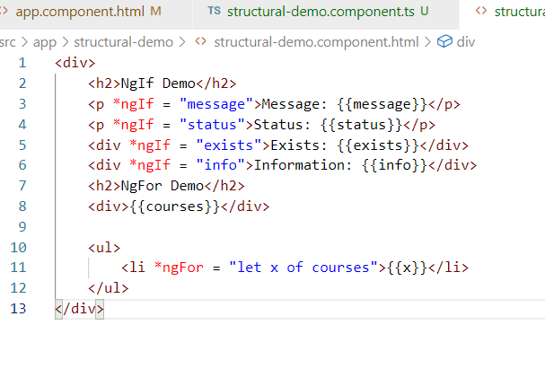

Here x iterates each item present in courses i.e., Javascript, Python, Java, C# and <li> is created as many times the iteration happens

Output:

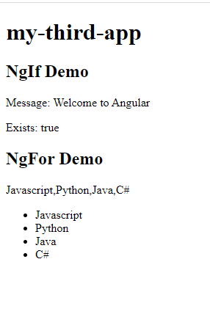

Activity:

1. Try Structural directive activities
2. Display the employee data present in the Javascript object given

employee = {id:100, name:”Ajay”, salary:45200}

Expected Output: Hello Ajay, your id is 100 and salary is 45200

1. Using Structural directive and Custom pipe iterate over an array of users and print users data in a table format, below is the user array

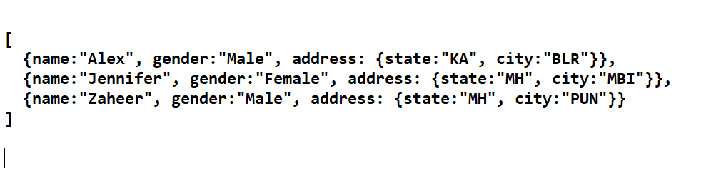

Expected Output:

|  |  |  |  |
| --- | --- | --- | --- |
| Name | Gender | State | City |
| Mr. Alex | Male | KA | BLR |
| Ms. Jennifer | Female | MH | MBI |
| Mr.Zaheer | Male | MH | PUN |
|  |  |  |  |

Note: You must use custom pipe that can format the name with the help gender

You can generate the pipe using ng generate pipe <<pipe-name>> or ng g p <<pipe-name>, this will automatically register the pipe in the AppModule and also creates a class with @Pipe({}) and implements PipeTransform

Solution:

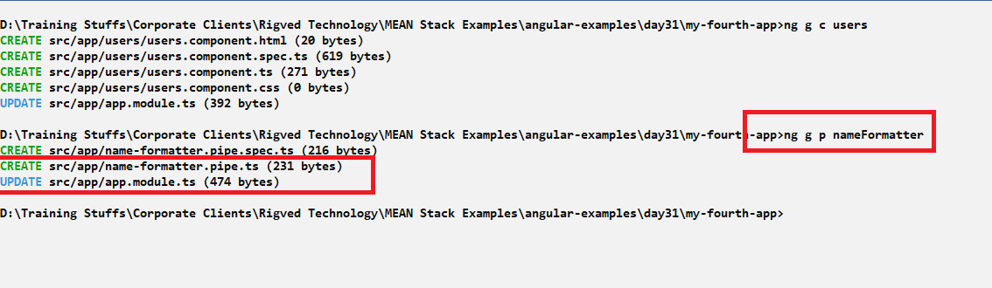

We created users component and added that in the root component, then we created a pipe with the name nameFormatter, the command does 50% of work like creating a class implementing PipeTransform, providing transform() function & registering the pipe in the app.module.ts

name-formatter.pipe.ts looks as below

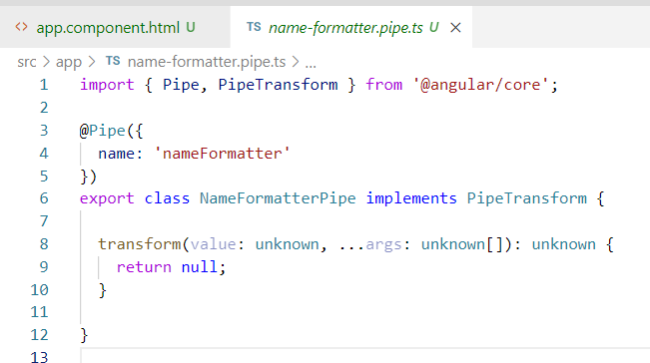

Note: You have to change the above pipe according to your requirement

You can see that pipe has been registered in app.module.ts

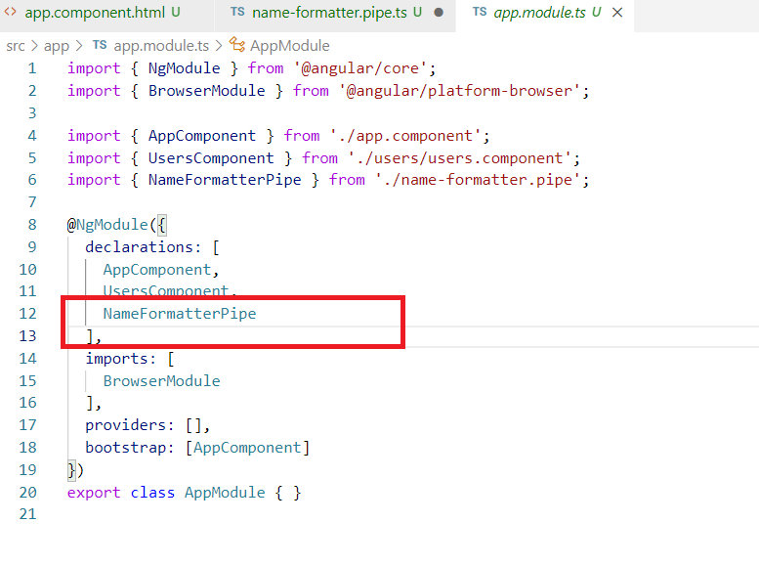

Changing the nameFormatter to take name and transform it based on the gender, i.e., we are going to using {{name | nameFormatter : gender}}, this nameFormatter is a pipe whose transform() is called by taking name in its 1st argument & gender in 2nd argument.

Here if name is Alex & gender is Male, then it must return Mr. Alex, similarly if name is Jennifer & gender is Female, then it must return Ms. Jennifer

name-formatter.pipe.ts

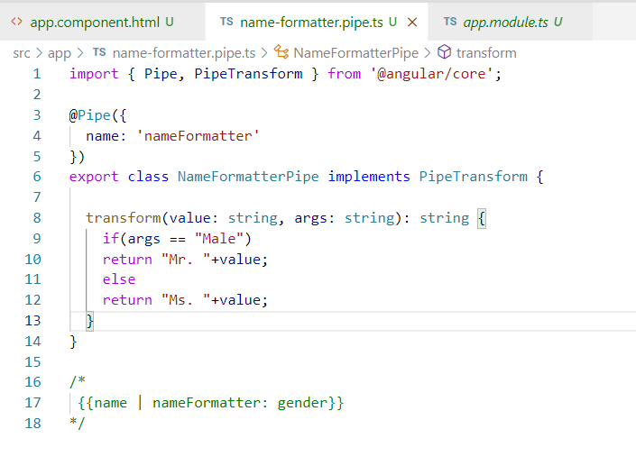

Now you need to use the nameFormatter pipe in users.component as it will have users array.

users.component.ts

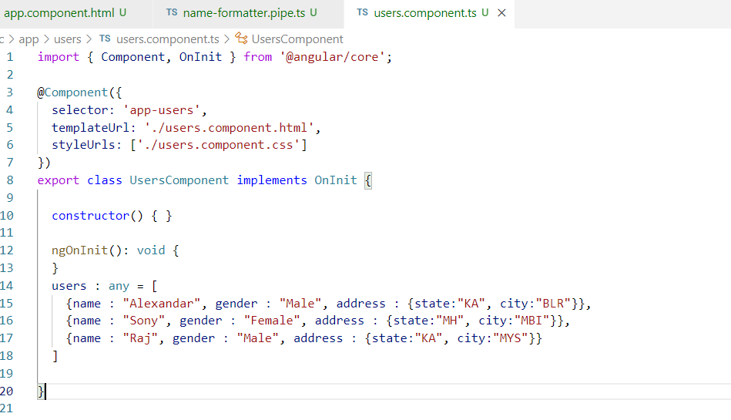

users.component.html

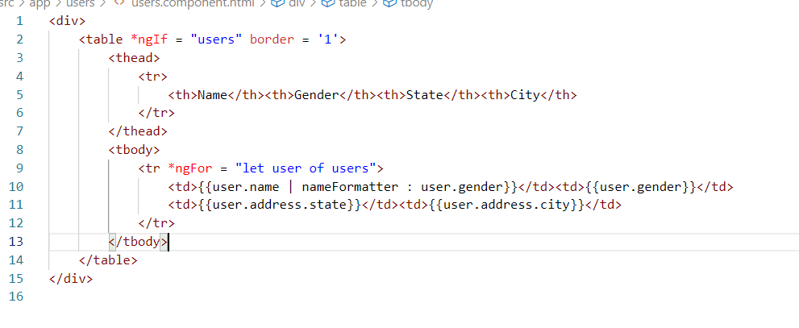

Output:

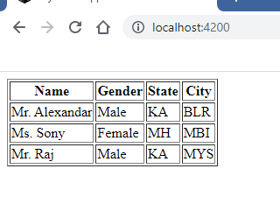

Adding bootstrap to our project

Bootstrap provides a good look and feel with the help of its predefined classes, you need to install bootstrap in your project and import it in styles.css so that you can globally use their classes in any component

Steps to add bootstrap in angular project

1. Download bootstrap js using npm, since jquery is another library that bootstrap depends on we need to install jquery also

i.e., npm install bootstrap jquery --save

Since some of the bootstrap functions call jquery functions we had to download jquery

1. Import the bootstrap css file location in the styles.css, the location of bootstrap css will be in node_modules folder
2. You can use bootstrap classes in your components

Installing bootstrap & jquery

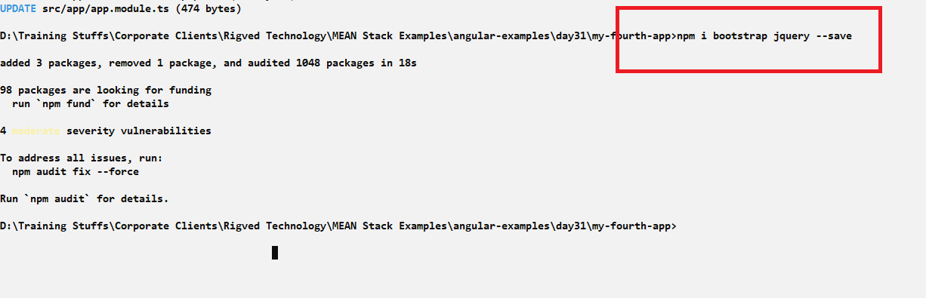

You can locate the bootstrap in node_modules/bootstrap/dist/css/… folder

Importing that location of css in styles.css

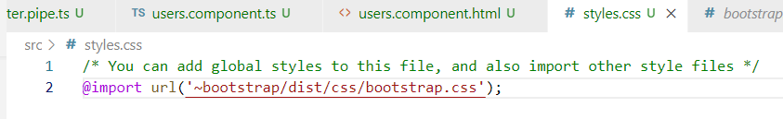

Now you can use all the bootstrap classes in your components like btn-primary, container-fluid, card, table, table-striped, form-group, form-control and etc.

Adding table class our components

users.component.html

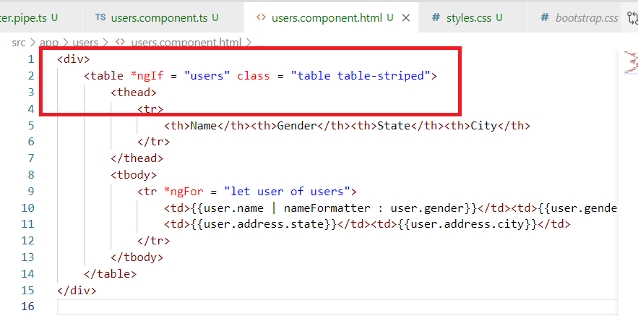

Output

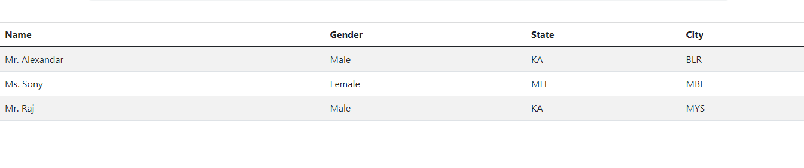

Using container-fluid in the app.component.html

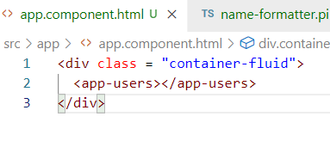

Output:

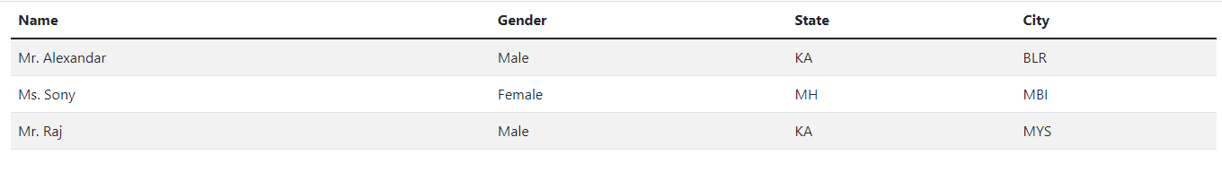

Apart from bootstrap you can add other third party libraries like

* semantic ui
* angular materials
* prime faces

Databinding in Angular

It is used to share the data between the view and the component and vice versa, here the component class needs data to perform some action and view also needs data to perform some action

There are mainly 4 types of databinding in angular

1. Interpolation {{data}}
2. Event Binding (eventName)
3. Property Binding [data]
4. Two way databinding [(data)]

Interpolation: It is used to share the data from component class to view, it is used by {{ }} syntax, it is mainly used to display the data present in the component. Interpolation supports not only accessing the component property it also supports accessing some predefined function of property and also perform some calculations

{{1 + 2}}

{{10 * 2}}

{{10 / 2}}

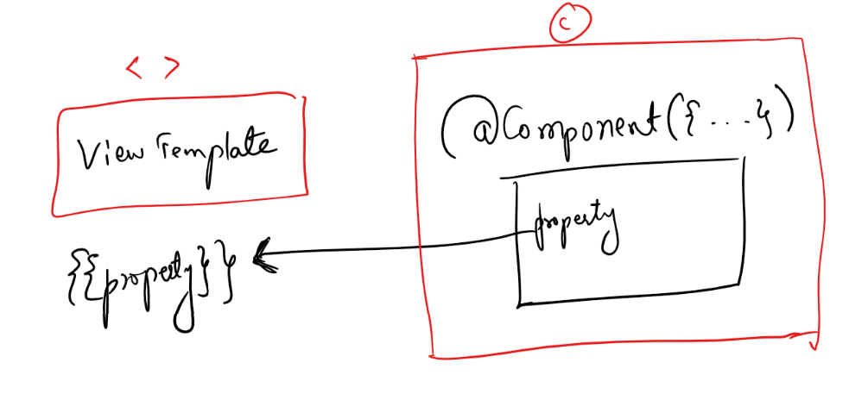

Note: The data flow in Interpolation happens in uni-direction i.e., one way databinding from component class to view template

Event binding: Here the data flow happens from view template to the component class, the data would flow to the component class when any event occurs in the view template, you need to wrap the event name in the parenthesis

(eventName) = action

Here the action would be the function call that updates the component data or passes the data to the component class

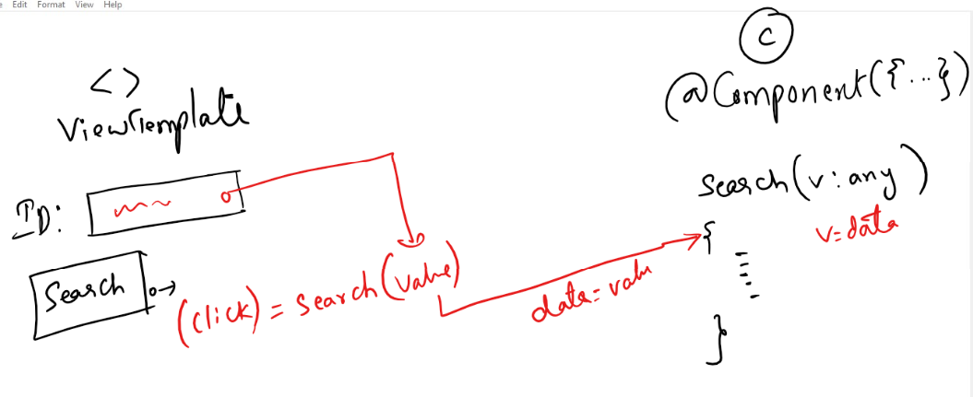

Note: Event binding is also one way data binding because the data flows in one direction from view to component class

Property Binding: Here the data flows from component class to view template and this is also one way data binding, the use of property binding is it can modify the DOM properties, it is used by adding dom properties in the square bracket

[domProperty] = data

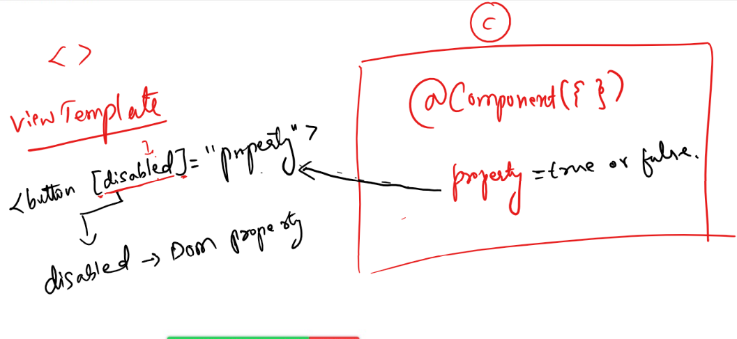

Note: Property binding also a one way data binding, where the data flows from component class to view template, it is mainly used to modify the DOM properties like disabled, innerText, hidden and etc.

ex: <p [hidden] = “data”>some content</p>

Now if the data is true then hidden = true, so content will be hidden, if data is false then hidden = false, so content will be shown.

Two way data binding: Here the data flows in both the direction from view to component class and vice versa, here the changes you made in view updates the component data and changes happening in component updates the view data, both will be in sync.

[(ngModel]) = “property”

The above expression updates the component data if changes happen in view and also updates the view if changes happen in component class.

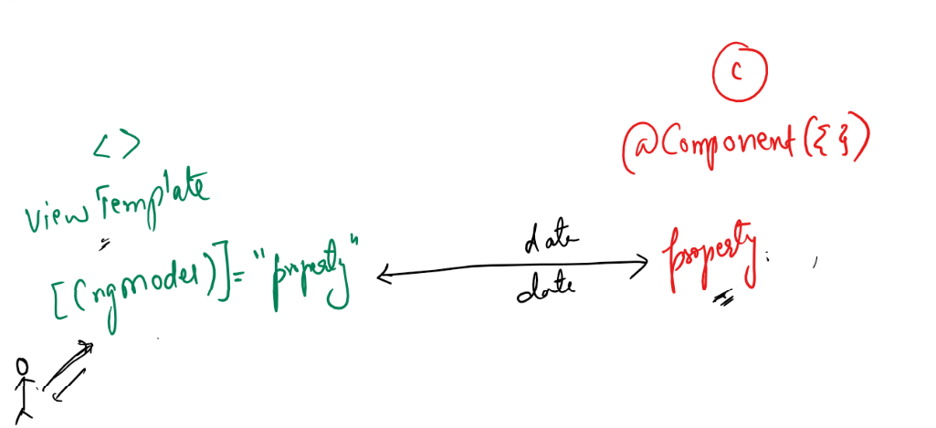

Note: ngModel is a directive which is by default not part of the application module, which needs to be added to the application module i.e., app.module.ts, you need to use FormsModule in the imports of @NgModule to add ngModel to your application, then only you can use [(ngModel)] in your view template

i.e.,

NgModule({  
 imports : […, FormsModule,….]  
})

Now you can use [(ngModel]) in the application.

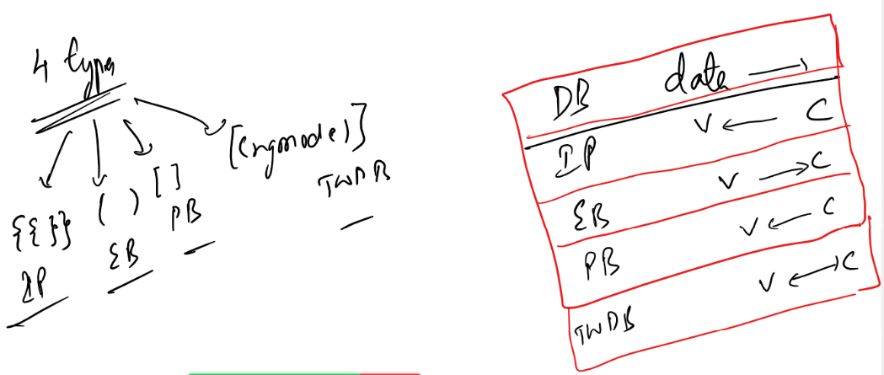

Event Binding:

Here the data flow happens from view template to component, the view template has to handle the event generated by the DOM elements and update the component property, there are many events that can be handled in the view template, some are

(click): Occurs when you click on DOM element

(input): Occurs when you enter input in the <input> element

(change): Occurs when any changes happen in the checkbox, radio, dropdown

(ngSubmit): Occurs when you submit the form

(focus): Occurs when you focus on a particular input element

(blur): It is opposite of (focus)

You can call a function present in the component that can modify the component property or pass the data to the component via function call

i.e.,

<input type = “button” (click) = “test(data)”>

Generate a component event-binding

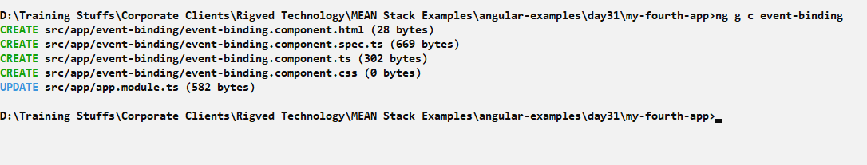

Add the event binding component in root component to see its output

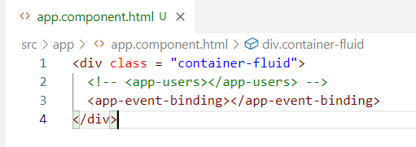

event-binding.component.ts

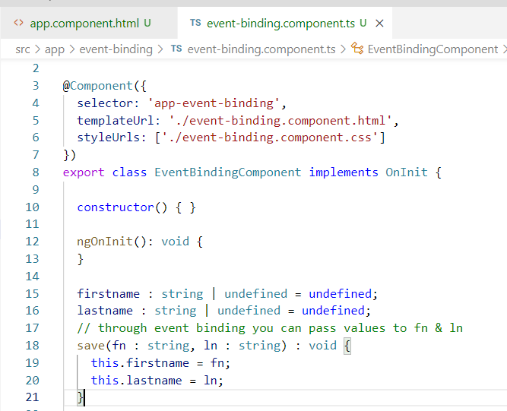

Here the save() function must be called from the view template of event-binding.component that passes value to fn & ln to initialize the firstname & lastname, to ensure there is changes happening in the firstname & lastname we can display it in the view template.

Template Reference Variables:

These are the names given to elements so that they are used by other elements to access element properties, they are used with #name,

<input #in>, now with the help of ‘in’ you can access the <input> element which has the name #in, here you can read its value by using in.value

event-binding.component.html

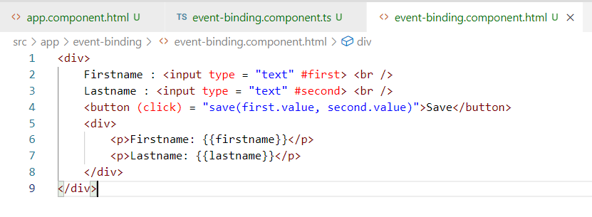

Here #first & #second are references to the elements, value is one of the property in the element that returns the value of the element, hence you are using first.value, second.value in the save once you click on the button.

Output:

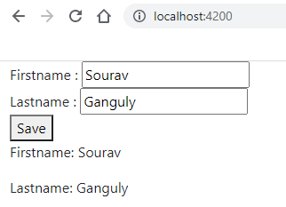

Here the (click) sends data to the component class and updates the firstname & lastname, however {{firstname}} & {{lastname}} are getting the data from the component class.

Property Binding

Here the DOM properties can be modified by getting the data from the component class, the view gets the data from component and update the DOM properties.

[domProperty] = “componentProperty”

Here domProperty could be hidden, disabled, innerText and so on

componentProperty could be true/false or some content depends on what dom property you are using

Create a component property-binding

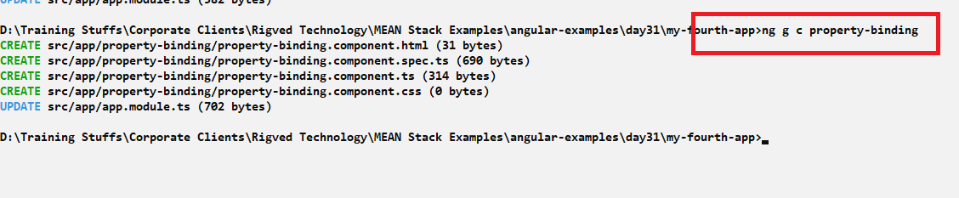

Add the component to root component to see the output of property-binding

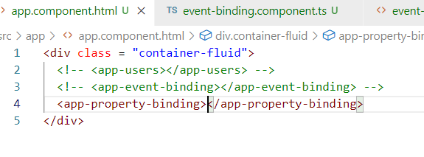

Create a function that changes a property from true to false and vice versa and use that property on any DOM elements to disable or enable the element

property-binding.component.ts

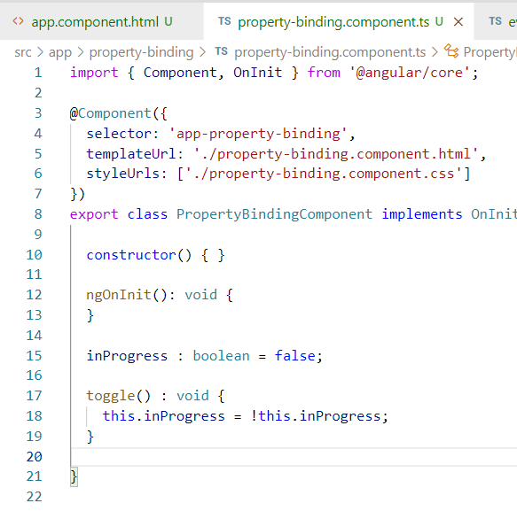

inProgress will toggle from true to false & vice versa, which is used to bind the DOM property however the toggle() is called by event binding method, here the inProgress is shared from component class to view template

property-binding.component.html

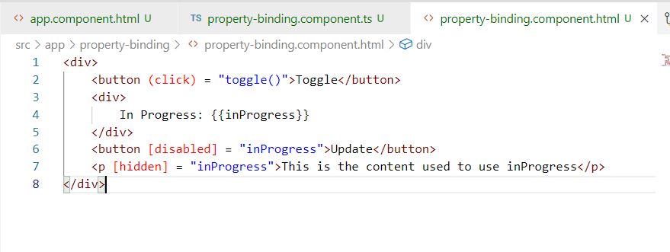

Here the data inProgress is shared from component to DOM element present in view template, the button is disabled when the isDisabled = true and also the <p> element is hidden when the hidden = true

Output:

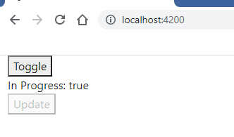

Activity:

1. Try above 3 types of data bindings & also use bootstrap in your application
2. Create 2 division with the help of bootstrap and in the same component add and display the elements

Output:

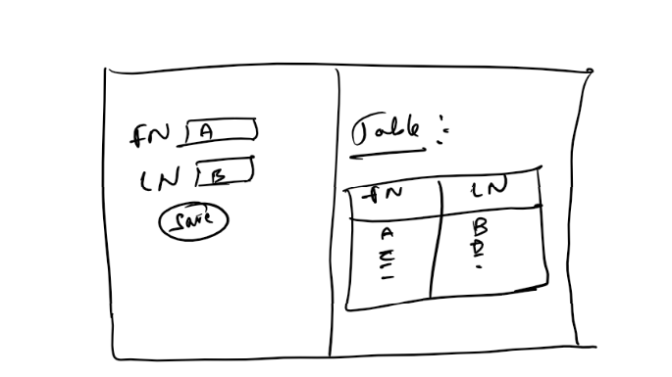

Two way data binding:

It is used to share the data in both directions the changes you make in view template is updated in the component class and changes you make in the component class is updated in the view template

[(ngModel)] is the directive used to achieve two way databinding, this directive is not recognized by angular by default, it is part of one inbuilt module FormsModule, which needs to be added in your application i.e., AppModule imports property

@NgModule({  
 ..

imports: [FromsModule,…]

..  
})  
export class AppModule

FormsModule is present in the @angular/forms library, it provides many directives which are useful in case of form handling like ngModel, ngForm

Create a component two-way-binding

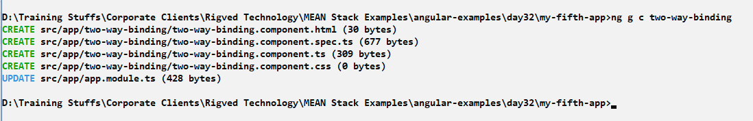

Add this component to the root component

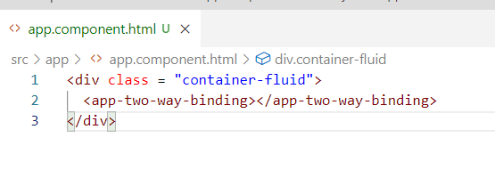

Note: You don’t’ have to add every new component in the root component, because there could be a scenario where you will add the new components to some child component which was part of either root or some other components, but root component will always be your top level component though your new components don’t directly be inside root.

Since you need to use ngModel, you need to add FormsModule in the @NgModule({}) of AppMcoule

app.module.ts

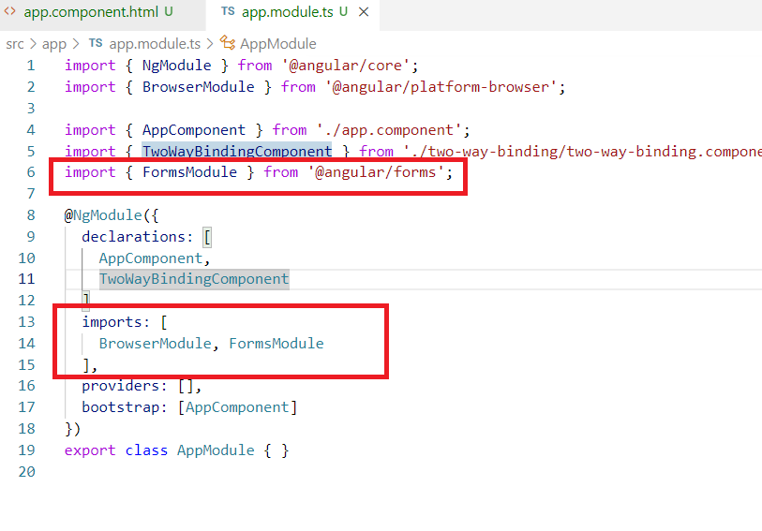

Now we can use the directives of FormsModule like ngForm, ngModel and so on.

ngModel: Allows you to achieve two way data binding, in both the direction the data will be in sync.

ngForm: Allows you to handle form data in angular

two-way-binding.component.ts

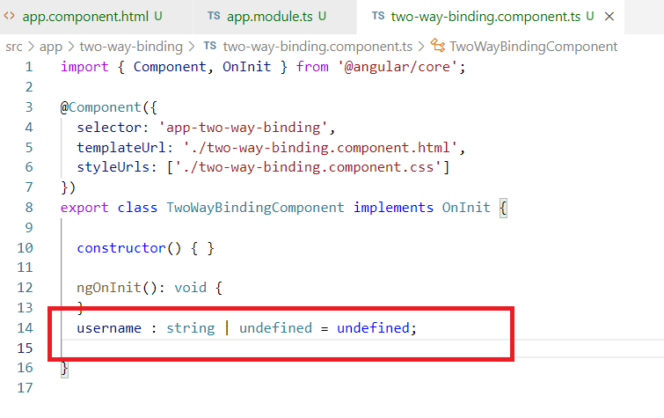

two-way-binding.component.html

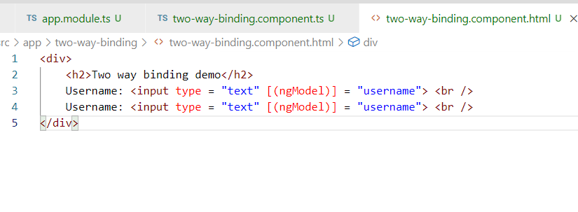

Here the [(ngModel)] = username, updates the username present in the component class as well as the view template using username i.e., <input> box itself, the reason 2 input box is created is to see the two way binding direction when one input box is updated another input box also updates, this proves that there’s a change happening in component class from view template

Output:

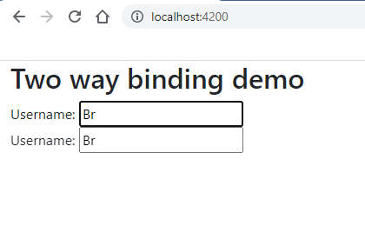

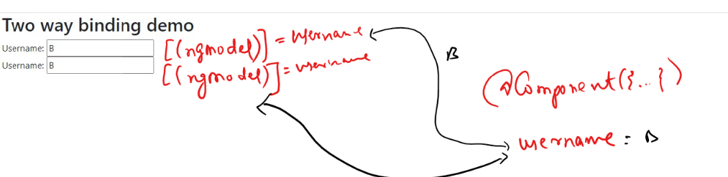

The code works only if the FormsModule is imported, if its not imported then you will get error in the command prompt & browser saying ngModel is not a known directive.

Suppose you removed or commented FormsModule in the app.module.ts -> imports

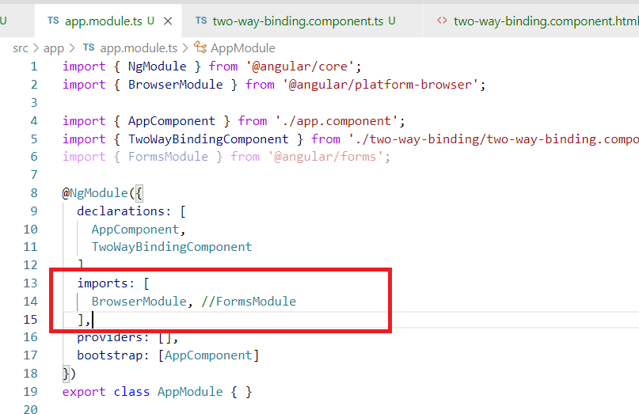

You will see error like below

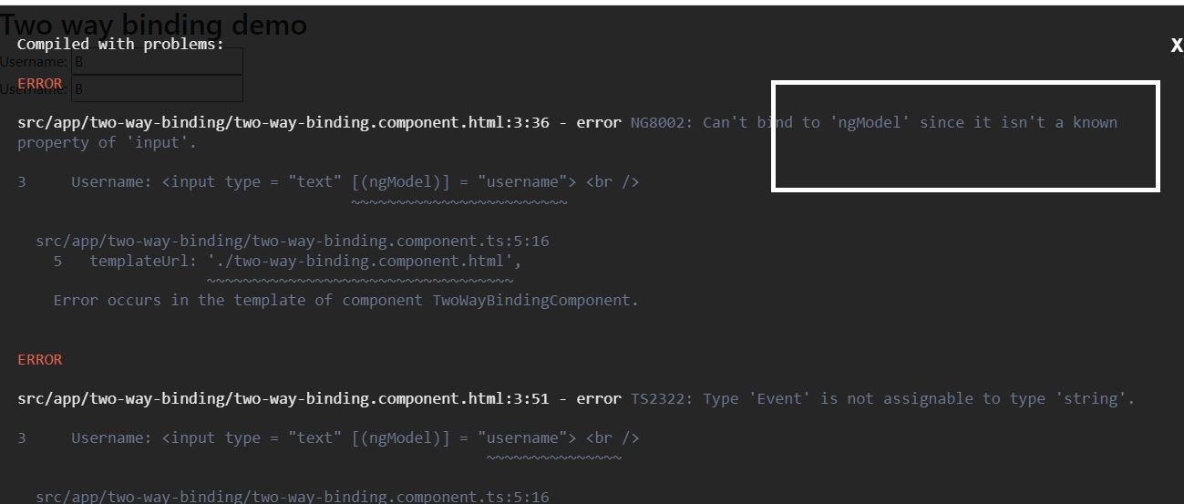

You can uncomment the FormsModule in the imports of app.module.ts

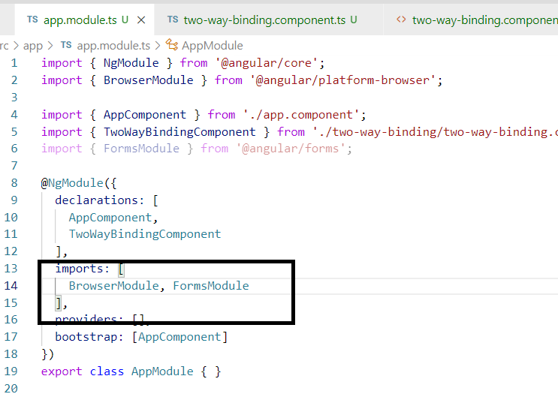

Output:

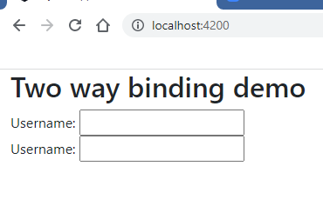

You can also bind multiple properties or a javascript object to the ngModel

app/user.ts

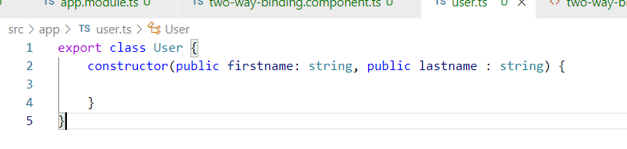

You can create object / variable of User type in two-way-binding.component.ts

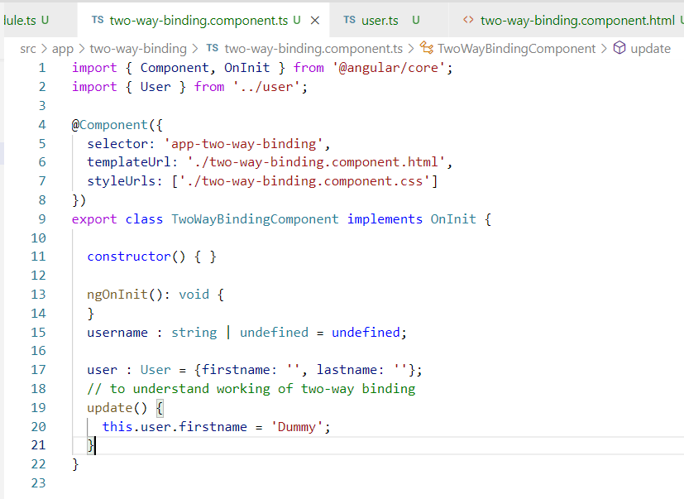

Note: update() is called via event binding that updates the component class property, and that reflects to the view template using [(ngModel)] as it is in sync

two-way-binding.component.html

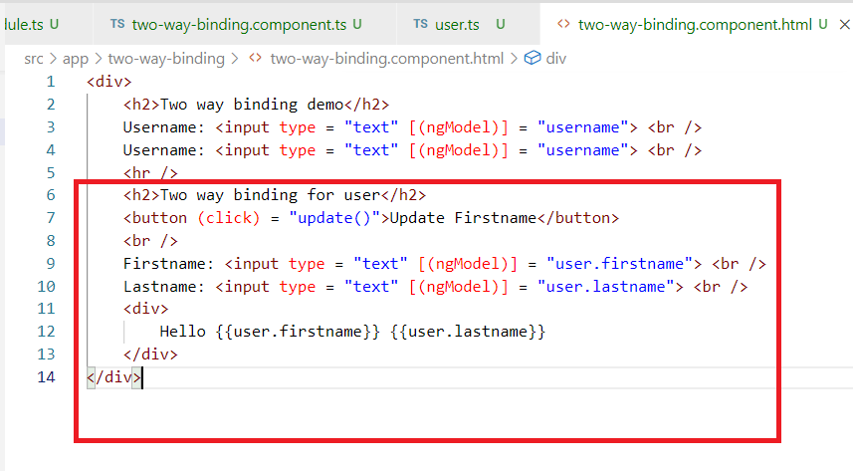

Output:

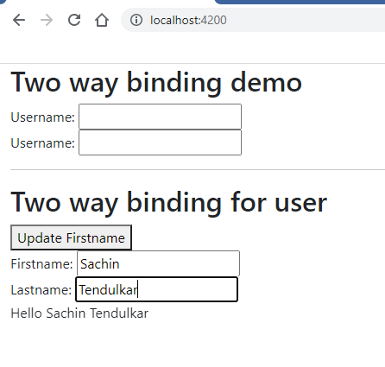

Apart from the above 4 types of bindings we also have other types of binding like

1. Attribute binding
2. Class binding
3. Style binding
4. @Input() and @Output() binding

Attribute binding: It is used when you want to bind the HTML attributes in the view template, it is used when there’s no property binding possible, probably because there wouldn’t be DOM property for the attribute

ex: <p [hidden]>: Here the hidden is a DOM property that angular uses to bind, same way you have <button [disabled] where disabled is also a DOM property but we don’t have a DOM property in certain elements like colspan, rowspan of <th>, <td> of <table>, the colspan & rowspan are not having any DOM properties in such cases we can bind to these attributes

<table [colspan] = “value”>: This doesn’t work because colspan is not a DOM property, but we can use <table [attr.colspan] = “value”> this is binding the attributes

We need to use attr.attribute-name to bind the attributes

Note: Use attributes binding for the elements when there’s no DOM property available for the elements

Create component attribute-binding

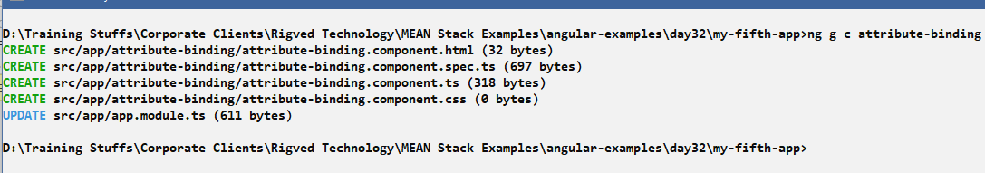

Add this to the root component

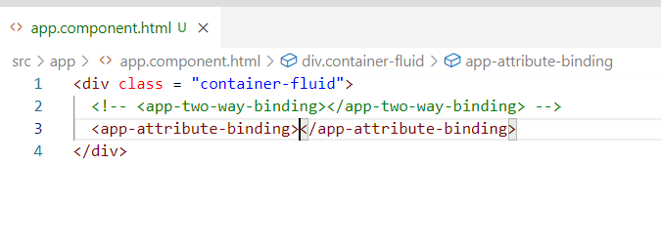

attribute-binding.component.ts

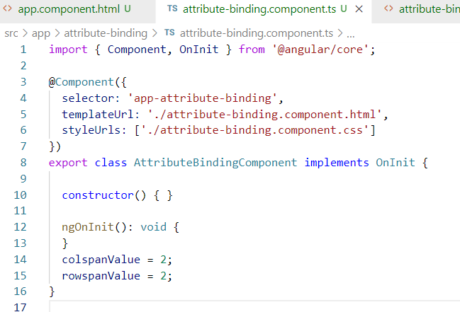

If you try to bind the colspanValue & rowspanValue to the <th> or <td> through Property binding you will get error.

i.e.,

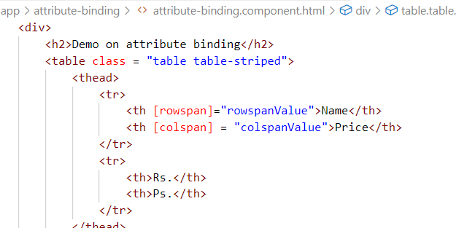

The error will be

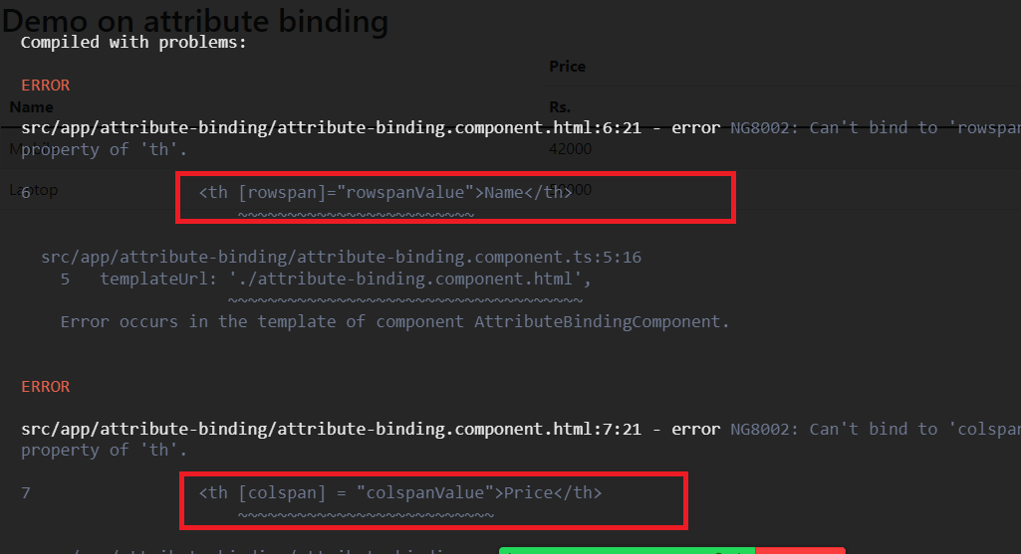

This error is because there’s not corresponding DOM properties for these attributes which some times works in the cases where you use attributes like hidden, disabled, style, class, because for all these attributes there are DOM properties available with the same name, but you don’t get DOM properties for the colspan & rowspan, hence you can’t bind with property binding syntax i.e, [colspan], [rowspan] which is a property binding means DOM property it binds.

To avoid error change attribute-binding.component.html

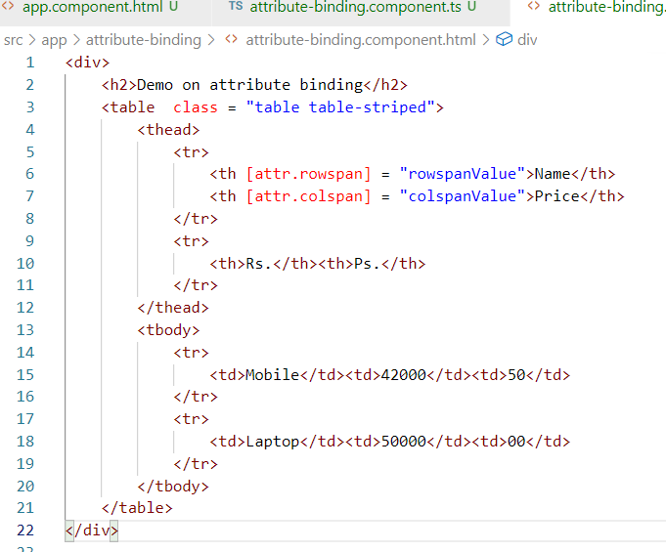

Output:

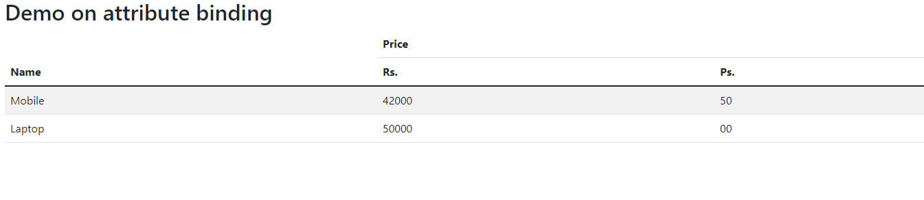

Attributes vs DOM properties

Attributes can’t be changed it is fixed however DOM properties can be changed at runtime

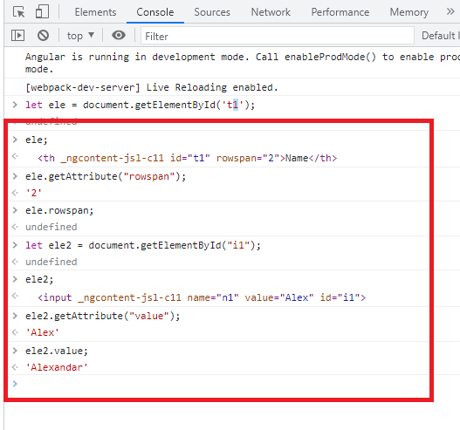

Here, ele is a reference to the <th id = “t1” rowspan = “2”>, since rowspan is an attribute you could see 2 in the ele.getAttribute(“rowspan”), but ele.rowspan gives undefined, because rowspan is not available as a DOM property

Similarly

ele2 is a reference to <input type = “text” id = “1” value = “Alex”>

ele2.getAttribute(“value”): will always give Alex

However ele2.value is a DOM property it gives the value you entered in the DOM ie.., in browser, since Alexandar is entered ele2.value gives Alexandar, we have DOM property for value attribute hence we got its value.

We can do a Property binding only for the DOM properties, but if the DOM properties are not available we can’t bind we get the error

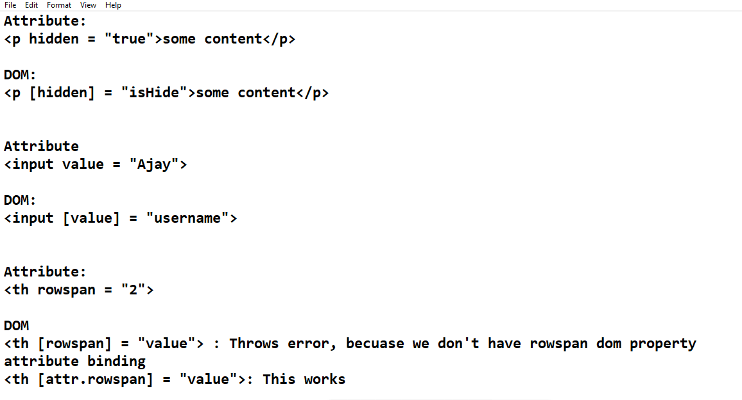

When to go for rowspan & colspan attribute binding

When the table rows & cols are decided at runtime and the spanning of some rows and cols need to be dynamic in that case you can use rowspan & colspan attribute binding

ex: Suppose you have a Mobile with different brands and all the brands should span to the Mobile then the Mobile must span according to the number of brands.

i.e.,

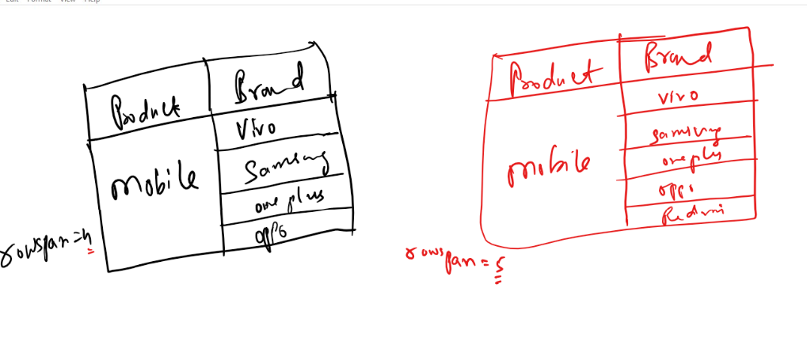

Style binding

It is also a type of property binding where you can add CSS to the style property

<p [style] = “myStyle”>

Here [style] is used to bind the style property and myStyle will have a value of CSS for the style like {“color”:”blue”, …}

Generate style-binding component

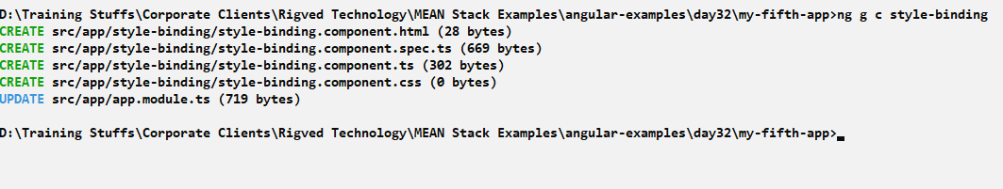

Add it to the root component

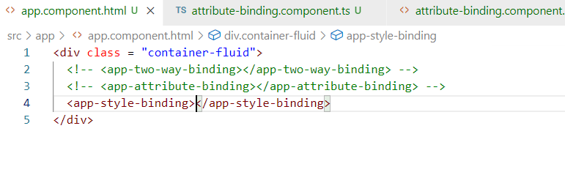

style-binding.component.ts

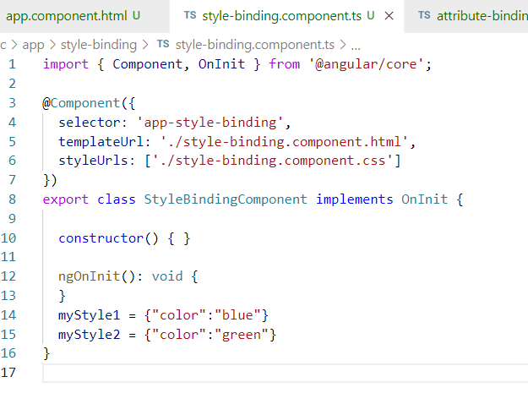

myStyle1 & myStyle2 can be used to bind the [style] property of the view template

style-binding.component.html

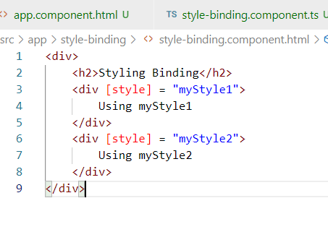

Output:

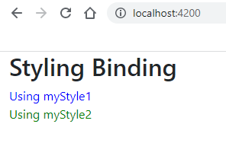

Class binding: It is used to add/remove the CSS classes defined in the CSS file, here you would set of css classes in css files that can be added or removed in the view template,

In case style binding the value will be provided by the component class, however in case of class binding the value is provided by CSS file with the help of true/false value from the component class, true means add the CSS & false means remove the CSS

CSS file

.rc { color : red }

Component file

apply = false or true

HTML file

<div [class.rc] = “apply”>

If apply is true then rc class is added else rc class will be removed

Generate the class-binding

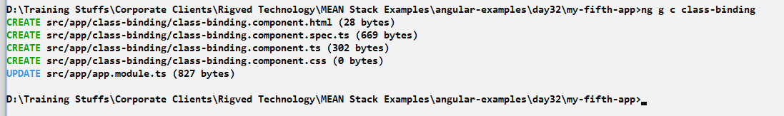

Add the class-binding to the root component

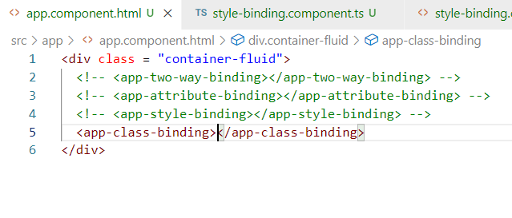

class-binding.component.ts

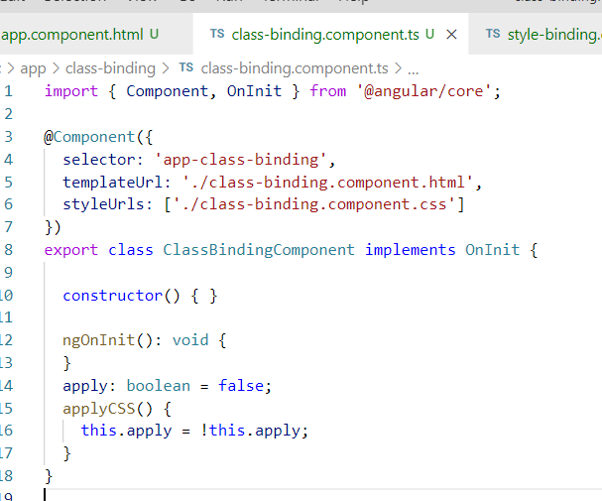

Here call on applyCSS changes value of apply to true/false alternatively.

Now you can add a class in the CSS file

class-binding.component.css

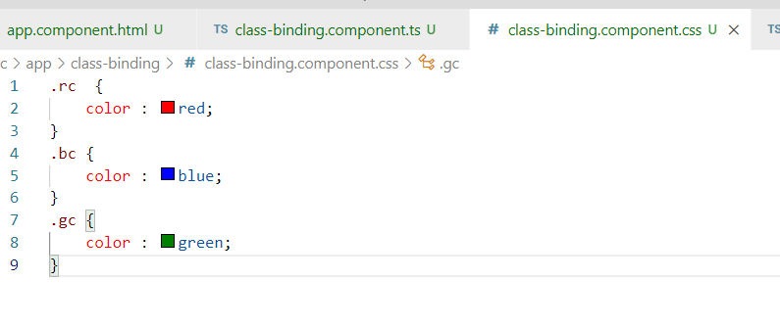

class-binding.component.html

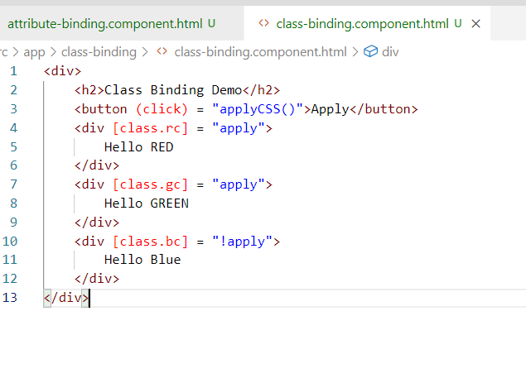

Here !apply reverse the value of apply

Output:

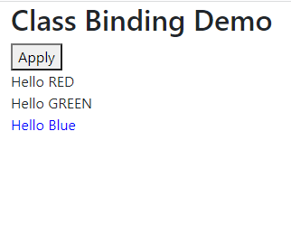

Activity:

1. Try all the above activities
2. Create a component to show the students record with marks, the student record must be shown in a table along with rollno, name, marks, the marks data must be have css style with red or green based on the value of marks, below is the student data you can use

students = [{rollNo:1, name: Ajay, marks: 40},{rollNo:2, name: Vijay, marks: 30},{rollNo:3, name: Manu, marks: 60},{rollNo:4, name: Sachin, marks: 20},{rollNo:5, name: Amit, marks: 70},{rollNo:6, name: Zaheer, marks: 80}]

Consider above student data and show the marks in red color when the marks is less than 40 and in green color when marks >= 40

1. Create a component that shows the product information with product name, brand name and spans the product name based on the number of brands you have, you can consider below products array to show the product name & brand name in the table format

products = [

{name: "Mobile", brand: ["Vivo", "Oppo", "Oneplus"]},

{name: "Laptop", brand: ["HP", "Dell", "Lenovo", "Acer"]}

]

The table must show name and brand by allocating the rows to product names as below

|  |  |
| --- | --- |
| Product Name | Product Brand |
| Mobile | Vivo |
| Oppo |
| Oneplus |
| Laptop | HP |
| Dell |
| Lenovo |
| Acer |